

**DESIGNING AND DEVELOPING APPLICATIONS ON THE CLOUD**

**INDIVIDUAL ASSIGNMENT**

|  |  |
| --- | --- |
| **Module** | **CT071-3-5-3-DDAC** |
| **Project Title** | **Online Flight Booking System (UIA)** |
| **Lecturer** | **DR. KALAI ANAND A/L RATNAM** |
| **Intake** | **UC3F1701SE** |
| **Student Name** | **Mohammad Kazem Hassan Nejad** |
| **Student ID** | **TP035903** |
| **Hand-in Date** | **9th October 2017** |

**Acknowledgement**

Prima facea, I would like to thank my parents for their unconditional support and unceasing encouragement throughout this project.

I would like to thank Dr. Kalai for sharing his pearls of wisdom and indebted to him for sharing expertise, and sincere and valuable guidance and encouragement extended to me throughout the project in the form of hands-on lab and other provided materials.

Lastly, I would like to thank Asia Pacific University for providing me the opportunity to excel academically by providing me all the necessary resources and facilities.

Table of Contents

1.0 Introduction 1

1.1 Background Information 1

1.2 Aim and Objectives 2

1.3 Scope 2

1.4 Major Functions 3

1.5 Assumptions 3

2.0 Project Plan 4

2.1 List of Tasks 4

2.2 Gantt Chart 4

3.0 Design 5

3.1 Design Modelling 5

3.1.1 Use Case Diagram 5

3.1.2 Entity Data Model 6

3.1.3 Sequence Diagram 7

3.1.4 View Map 9

3.2 Interface Design (UI Mockup) 10

3.3 Cloud Architecture Diagram 14

4.0 Implementation 16

4.1 Core Application Implementation 16

4.1.1 External Configuration Store (Cloud Design Pattern) 16

4.1.2 Security and Authentication 17

4.1.3 Dynamic Seat Picker 19

4.1.4 GeoIP-based Currency 21

4.1.5 Developed Web Pages 24

4.2 Cloud Implementation and Deployment 38

4.2.1 Cost Breakdown 38

4.2.2 Web App 41

4.2.3 Azure SQL Database 45

4.2.4 Traffic Manager 49

4.2.5 Application Insights 52

4.2.6 Azure Blob Storage 55

5.0 Testing 56

5.1 Test Plan 56

5.1.1 Functional Testing 56

5.1.2 Performance Testing 61

5.2 Results & Analysis 62

5.2.1 Functional Tests 62

5.2.2 Performance Tests 63

6.0 Conclusion 70

Appendices 73

##### List of Figures

Figure 1. Use Case Diagram 5

Figure 2. Entity Data Model 6

Figure 3. Search Flight Sequence Model 7

Figure 4. Booking Sequence Model 7

Figure 5. Register Sequence Model 7

Figure 6. Login Sequence Model 8

Figure 7. Edit User Sequence Model 8

Figure 8. MVC View Map 9

Figure 9. Homepage/Search for flight Mockup 10

Figure 10.Search Result Page Mockup 11

Figure 11. Login Page Mockup 11

Figure 12. Register Page Mockup 12

Figure 13. Booking Page Mockup (1/3) 12

Figure 14. Booking Page Mockup (2/3) 13

Figure 15. Booking Page Mockup (3/3) 13

Figure 16. Edit Profile Page Mockup 14

Figure 17. Proposed Cloud Architecture Diagram 15

Figure 18. External Configuration Store Diagram (Narumoto, et al., 2017) 17

Figure 19. Upload Config Blob - Code Snippet 17

Figure 20. Config Checker Run - Code Snippet 17

Figure 21. Anti-forgery token Generation and Validation in View and Controller 18

Figure 22. Authorize and AllowAnonymous Tags 18

Figure 23. OWIN-based Authentication - ASP.NET Identity 19

Figure 24. Boeing 737 SVG Seat Layout (AnyChart, 2017) 20

Figure 25. Div Tag to hold Seat SVG graph and Selected Seat - Code Snippet 20

Figure 26. Generate and hold SVG graph – Code Snippet 20

Figure 27. Update Selected Seat - Code Snippet 21

Figure 28. User IP Address (v4) based on Request variables 21

Figure 29. GetIPLocation - Code Snippet 22

Figure 30. Currency based on IP - Code Snippet 22

Figure 31. User Request from Malaysia - Ringgit Currency 23

Figure 32. User Request from Finland - Euro Currency 23

Figure 33. Homepage Implemented Design 24

Figure 34. Available Flights Implemented Design 25

Figure 35. Register Page Implemented Design 26

Figure 36. Login Page Implemented Design 27

Figure 37. Homepage with logged in user 28

Figure 38. View Bookings Implemented Design - No bookings 29

Figure 39. Edit Profile Implemented Design 30

Figure 40. Change Password Implemented Design - Profile 31

Figure 41. Search Result Page - Implemented Design 32

Figure 42. Book Flight Ticket Implemented Design - Part 1 33

Figure 43. Book Flight Ticket Implemented Design - Part 2 34

Figure 44. Book Flight Ticket Implemented Design - Part 3 35

Figure 45. Booking Confirmed Page 36

Figure 46. View Bookings Implemented Design 37

Figure 47. Traffic Manager - Cost Breakdown 39

Figure 48. Azure SQL Database - Cost Breakdown 39

Figure 49. Blob Storage - Cost Breakdown 39

Figure 50. Web Application S1 - Cost Breakdown 40

Figure 51. Web Application S2 - Cost Breakdown 40

Figure 52. Web Application S3 - Cost Breakdown 41

Figure 53. Basic vs Standard Pricing Tier 42

Figure 54. SEA-deployed Web App 43

Figure 55. West Europe Web App 43

Figure 56. Continuous Deployment on Azure Web App 44

Figure 57. GitHub Repository 44

Figure 58. Scale-out during high demand 45

Figure 59. SQL Database Service Tier Comparison (Rabeler, et al., 2017) 46

Figure 60. Chosen Database Service Tier 47

Figure 61. Database Server Location 47

Figure 62. SQL Server 48

Figure 63. Database Security Settings 49

Figure 64. Traffic Manager Performance Routing Method (Dwivedi, et al., 2017) 50

Figure 65. Traffic Manager Endpoints 51

Figure 66. Traffic Manager Configuration 51

Figure 67. Application Insights - Failures 52

Figure 68. Example of exception during failure 53

Figure 69. Performance Metrics - Application Insights 54

Figure 70. Response Time Visual Map 54

Figure 71. Response Time Analytics - Application Insights 54

Figure 72. Configuration Container – Blob Storage 55

Figure 73. Auditing Log Container - Blob Storage 55

Figure 74. Performance Metrics - S1 - 100 Concurrent Users 63

Figure 75. Performance Metrics - S1 - 300 Concurrent Users 64

Figure 76. Performance Metrics - S1 - 500 Concurrent Users 65

Figure 77. Performance Metrics - S1 - 1000 Concurrent Users 66

Figure 78. Throughput across service tiers with varying concurrent user load chart 67

Figure 79. Latency across service tiers with varying concurrent user load chart 68

**List of Tables**

Table 1. Functional Test Plan 57

Table 2. Performance Test Plan 61

Table 3. Functional Test Results 62

Table 4. Throughput every second across varying user load and service tiers 67

Table 5. Average Response Time across varying user load and service tiers 68

# 1.0 Introduction

## 1.1 Background Information

In 1992, Ukraine International Airlines was established as a global airline of the autonomous Ukraine by the Ukrainian State Association of Civil Aviation and GPA, the world's largest aircraft lessor (Lavrov & Gordiienko, 2014). Within the past 15 years, the airline has allured some of the worlds' top business and strategic investors. At first, UIA was intended to set up constant operations amongst Ukraine and Western Europe and effectively remain as a passenger carrier airline (Lavrov & Gordiienko, 2014). In 2009, which marked UIA's 18th commemoration, they ended up as one of Ukraine's key aviation competitor through the domination of over 20% of the market.

In the midst of the competitive environment and extraordinary cost-based rivalry, UIA took a step forward to transform their business adaptability and permitted beginning change from a point-to-point into an international network airline (Lavrov & Gordiienko, 2014). In 2013, after the business fall of the primary competitor, UIA ended up being the sole airlines with its level of infrastructural influence within the Ukraine market. The change procedure ended up being significantly more unique than it had been arranged at first. Over the next year, UIA doubled in size in terms of number of aircrafts and amidst the political and economic instability, and the debasement of the Ukrainian currency, UIA was striven to remain competitive through strategical overhauls to their staff, routes, and carriers resulting in reduction in ticket fares to enable them to further internationalize their services and contend as one of the world's low-fare carriers (Lavrov & Gordiienko, 2014).

UIA has long used technology to help reduce costs and improve customer service. With the advancements in technology, and maturation of cloud computing, the Chief Information Officer, Dmitrity Prudnikov, has realized that through migration of their website out of their own datacenters into the public cloud, they can gain a competitive advantage over their competitors and improve customer services with the extensive set of tools and services that are provided. UIA has considered the different available public cloud platforms, and has chosen Microsoft Azure, due to a range of reasons, including its compatibility with open source software.

## 1.2 Aim and Objectives

The aim of the project is to design and develop a single-tenant flight booking web application that will aid in the reduction of costs and improvement of customer service. The objectives of the project are:

1. Develop and implement an intuitive Ukraine International Airlines (UIA) flight booking web application.
2. Deploy the web application as an Azure App Service in two different regions.
3. Create and configure an Azure SQL database for the storage of customer data.
4. Implement traffic manager to balance load and optimize performance during peak seasons as well as providing scaling out/in to meet the demands at any given time.
5. Implement security measurements for the protection of the data on the database.

## 1.3 Scope

The scope of the project has been well-defined as follows:

* The web application will be hosted in the two most appropriate regions to server as a proof of concept.
* The web application will consist of all the necessary functions for the pedestal needs of a customer in regard to booking a flight.
* The public cloud platform that will be used to deploy the web application is Microsoft Azure.
* Platform as a Service (PAAS) will be used within Microsoft Azure.
* The chosen Azure services and design considerations are based on the constrained budget of RM 150.
* The web application will enhance the usability through customized information, however it will only consist of currency changes with no actual conversion of the monetary value.
* The web application will exclude administrative actions, such as flight management.

## 1.4 Major Functions

The major functions of the web application are to provide:

* Create customer profile
* Login to the system
* Search for flight
* Select a seat using a dynamic seat picker.
* View customized ticket and booking information based on the user’s geographical location.
* View and edit customer profile

The major functions provided through deployment on Microsoft Azure are as follows:

* Traffic management to direct and reduce the user load across the deployed web applications in the varying regions.
* Performance optimization through numerous performance tests
* Continuous deployment of the latest committed changes to the web application.
* Storage of customer data on Azure SQL database
* Scale-out to meet the needs of demands during peak seasons

## 1.5 Assumptions

There are numerous assumptions that set the basis for undertaking this project, which are as follows:

* There are flights from every airport to every other airport on a daily basis.
* There is a limited budget of RM 150 to be expended on the Azure services.
* The fleet used by UIA are all of the same aircraft type, which is the Boeing-737.
* The development team is situated in Malaysia.
* The project serves as a proof-of-concept rather than the delivery of a complete flight booking system with all the possible Azure services without a constrained budget.

# 2.0 Project Plan

## 2.1 List of Tasks

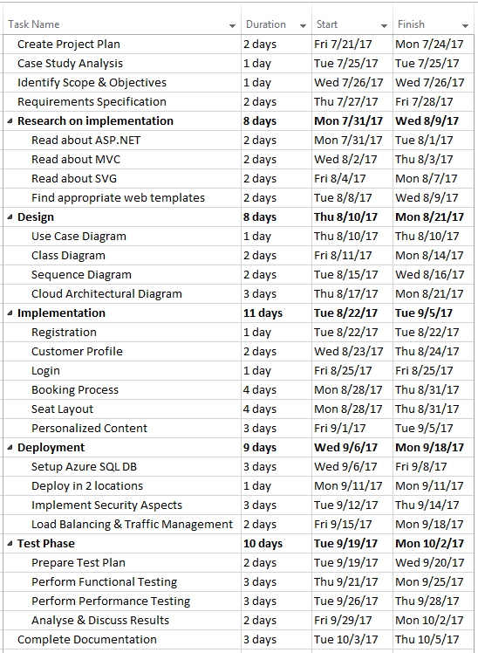

## 2.2 Gantt Chart

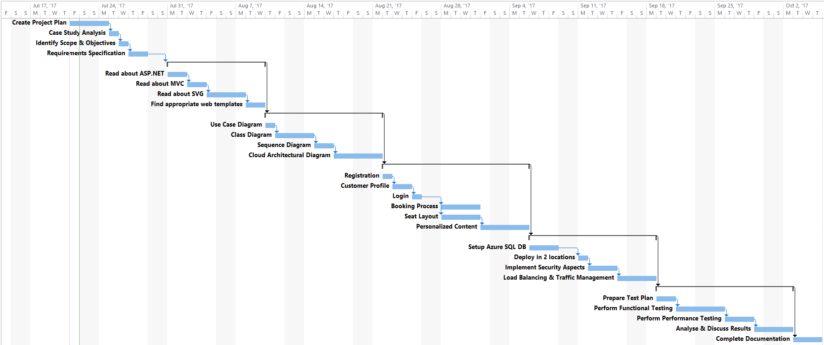

# 3.0 Design

## 3.1 Design Modelling

### 3.1.1 Use Case Diagram

The diagram below illustrates the various use cases that have been defined as per the requirements needed for the customer to manage their entire booking process, create a profile, and view customized information to enhance their usability.

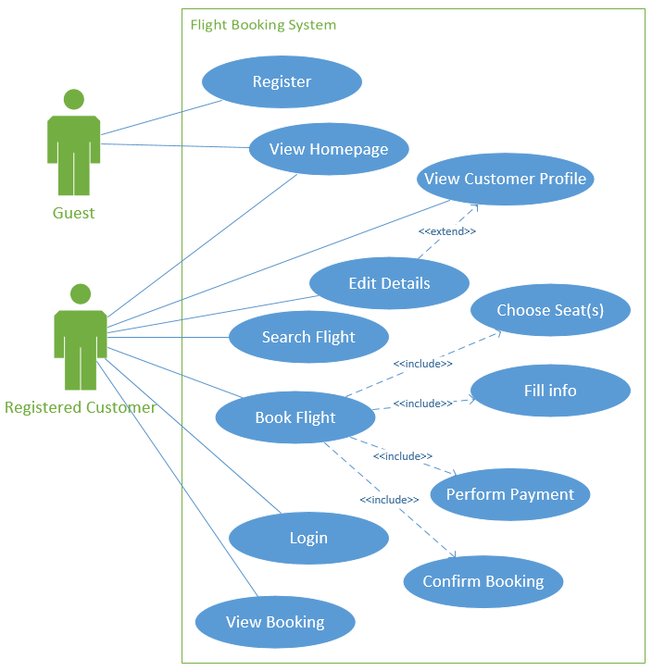

Figure . Use Case Diagram

### 3.1.2 Entity Data Model

The figure below illustrates the entity data model diagram that was designed as part of the proposed MVC architecture. It depicts the relational database entities in a similar format as to an Entity-Relationship Diagram (ERD).

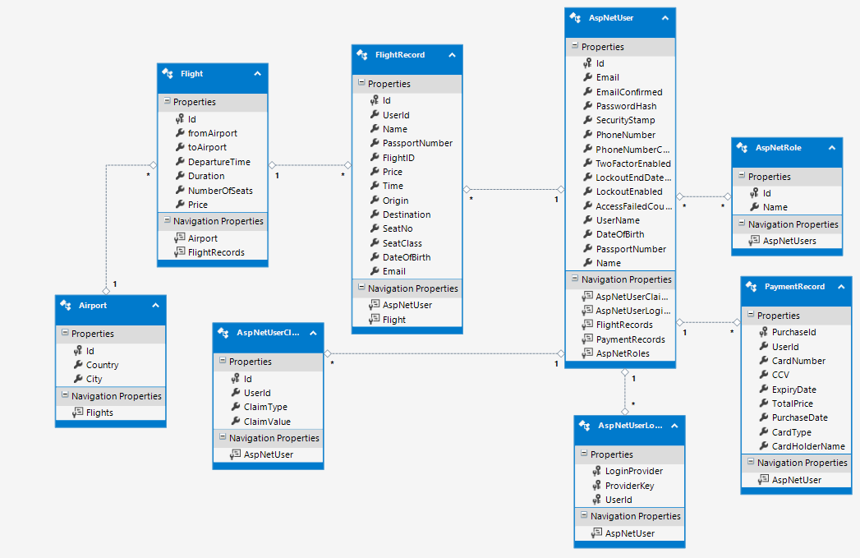

Figure . Entity Data Model

### 3.1.3 Sequence Diagram

The sequence diagrams below depict the various scenarios as defined in the use case using the Model-View-Controller (MVC) architecture.

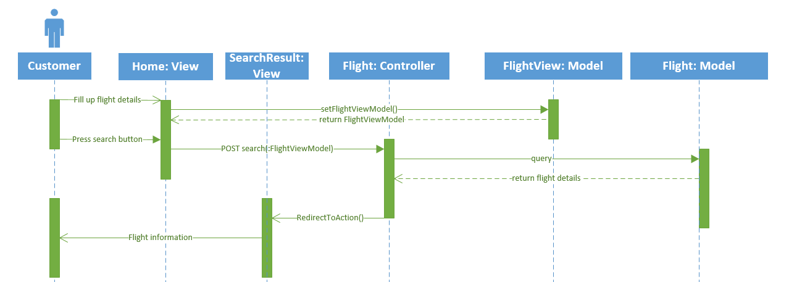

Figure . Search Flight Sequence Model

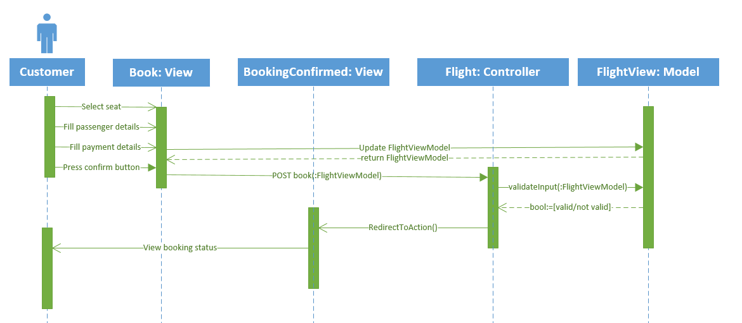

Figure . Booking Sequence Model

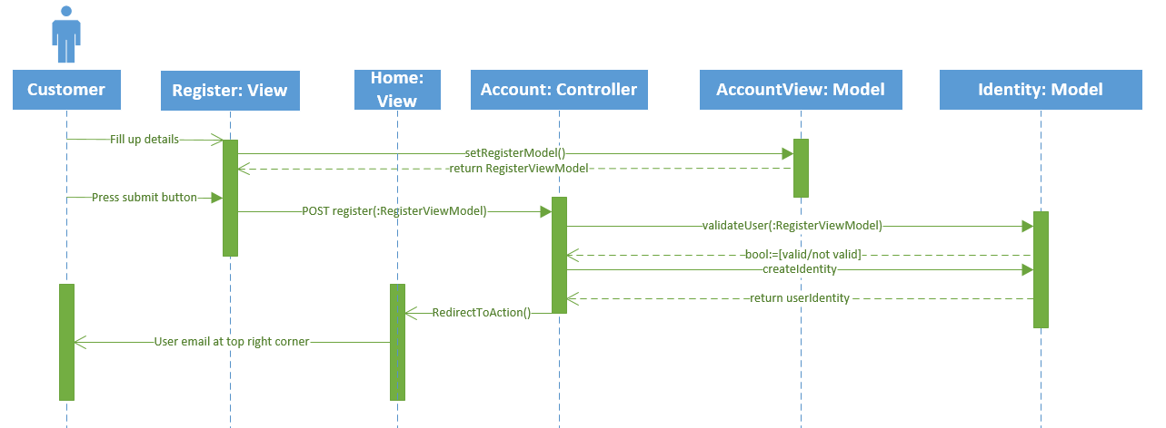

Figure . Register Sequence Model

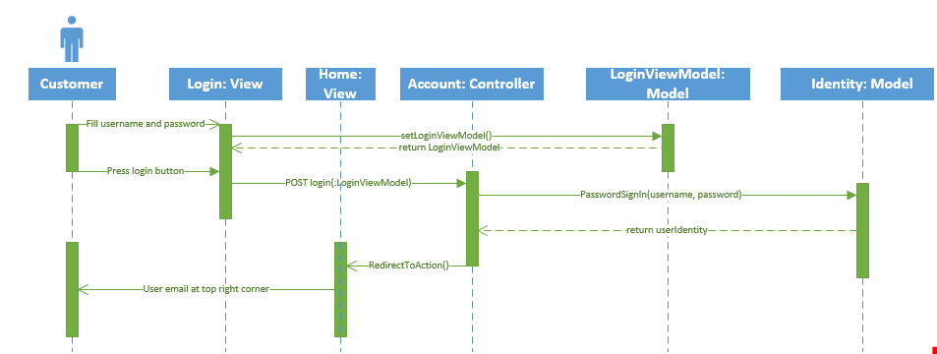

Figure . Login Sequence Model

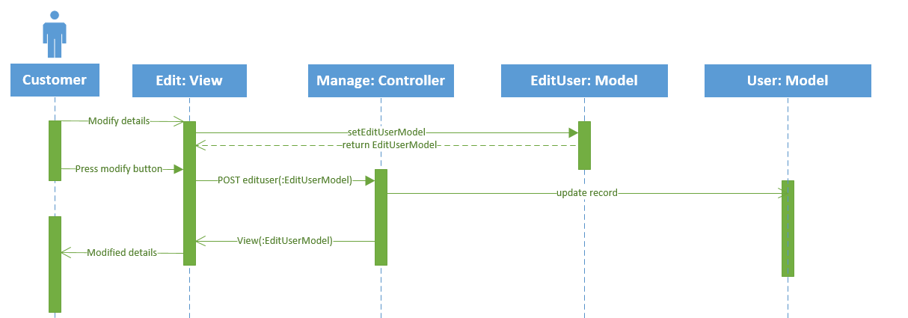

Figure . Edit User Sequence Model

### 3.1.4 View Map

The diagram below depicts the overall structural mapping of the various views within the proposed MVC architecture. It displays 14 view (web pages) that have been proposed to be implemented in the project.

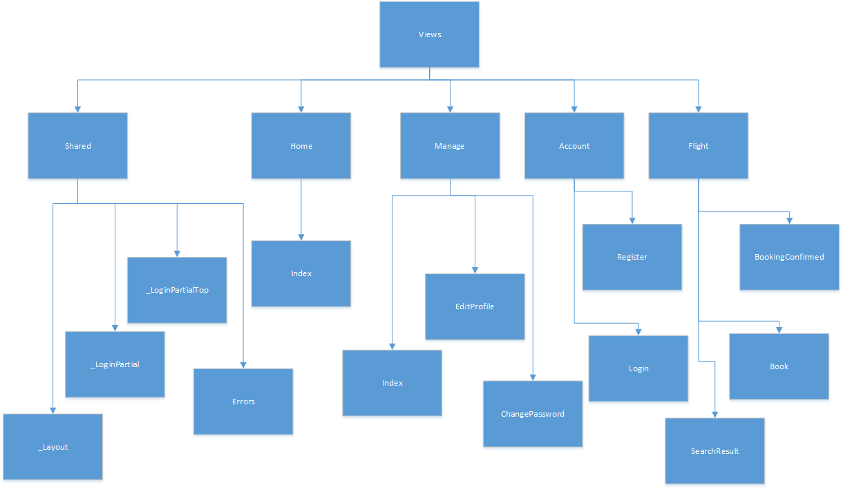

Figure . MVC View Map

## 3.2 Interface Design (UI Mockup)

The figures below illustrate the various abstract interface mockups for the web application that is to be developed. This guides the developer with the ability to contextualize the user requirements based on the design.

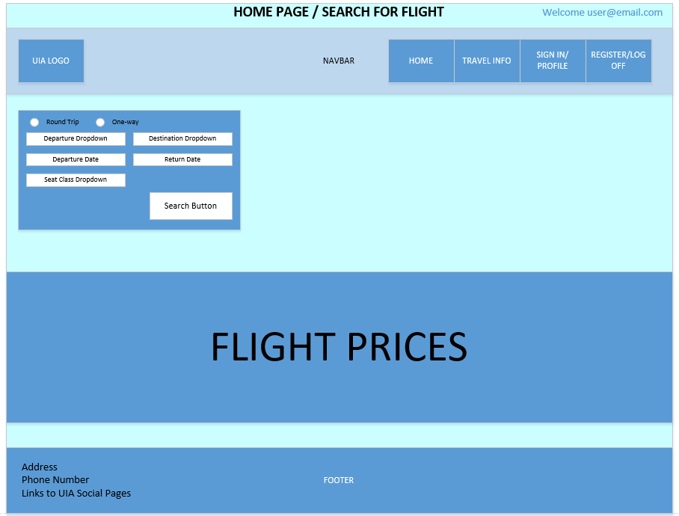

Figure . Homepage/Search for flight Mockup

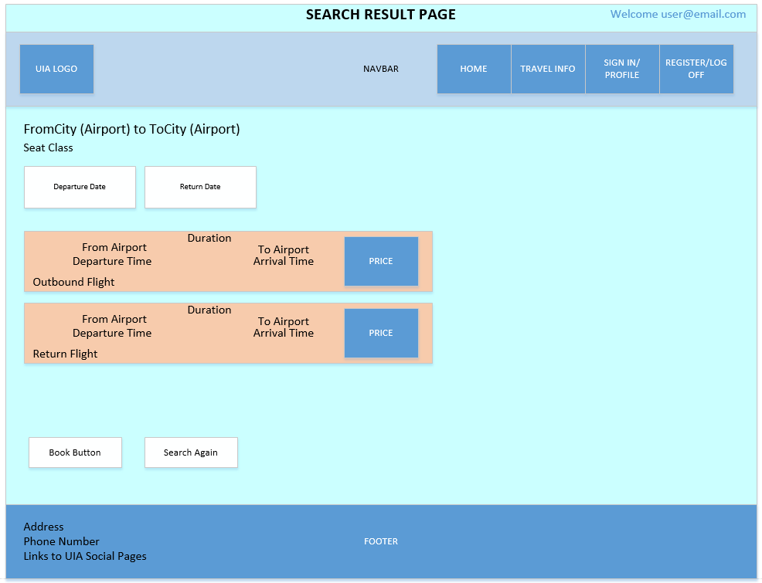

Figure .Search Result Page Mockup

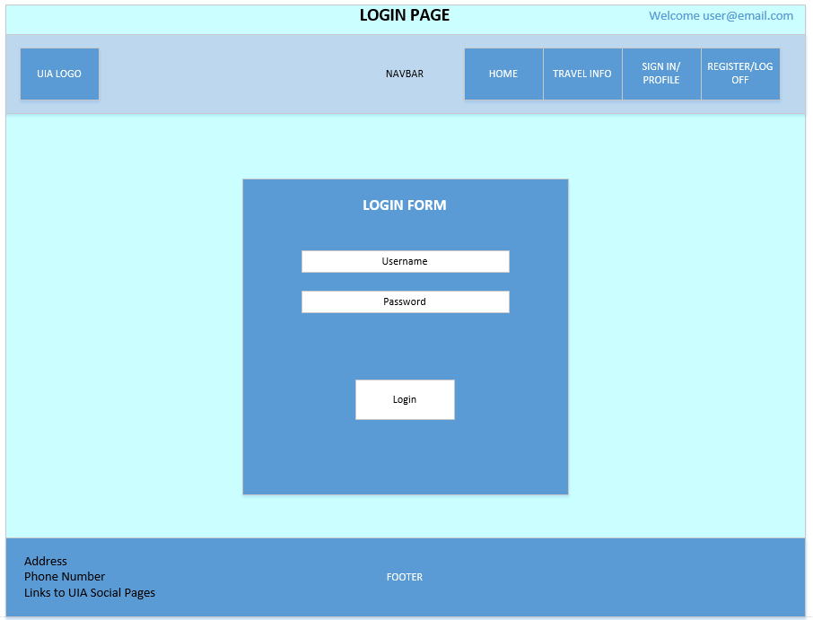

Figure . Login Page Mockup

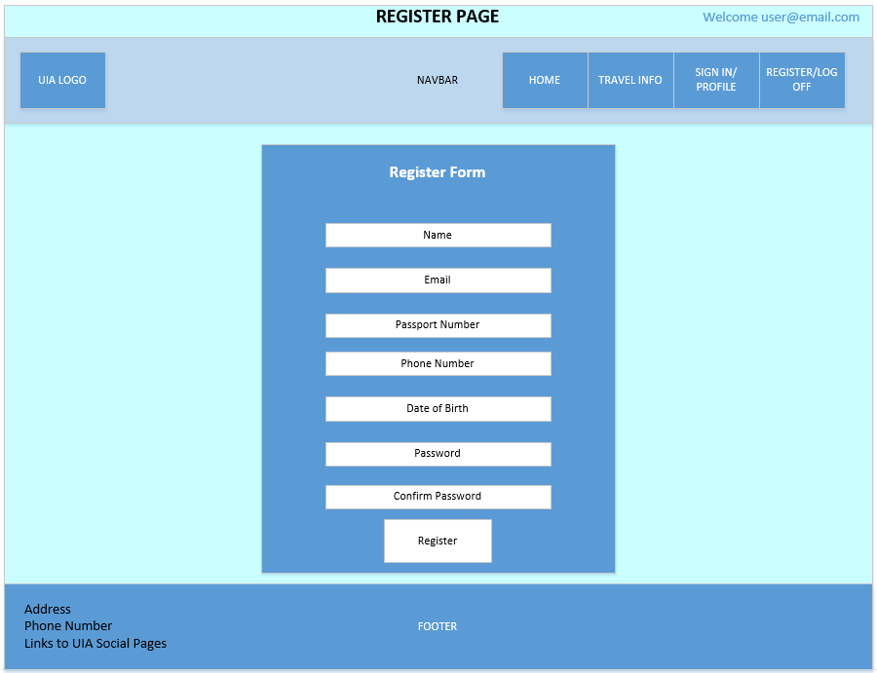

Figure . Register Page Mockup

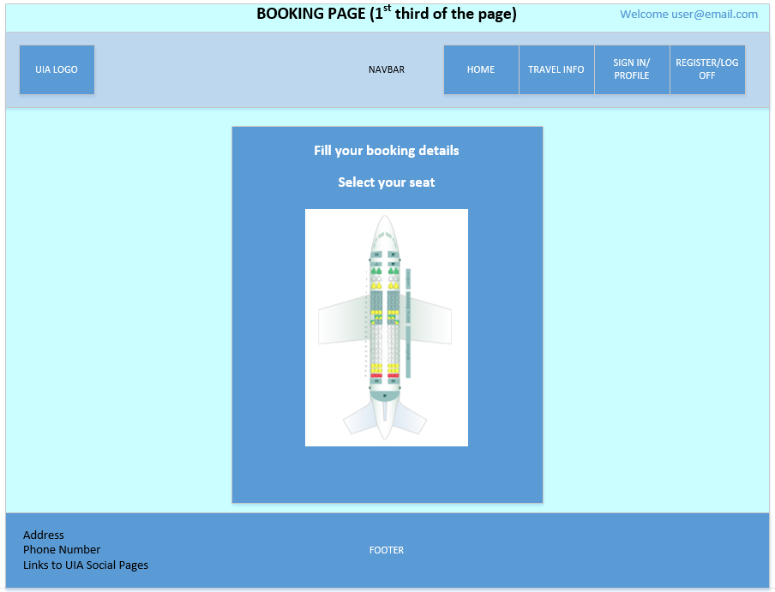

Figure . Booking Page Mockup (1/3)

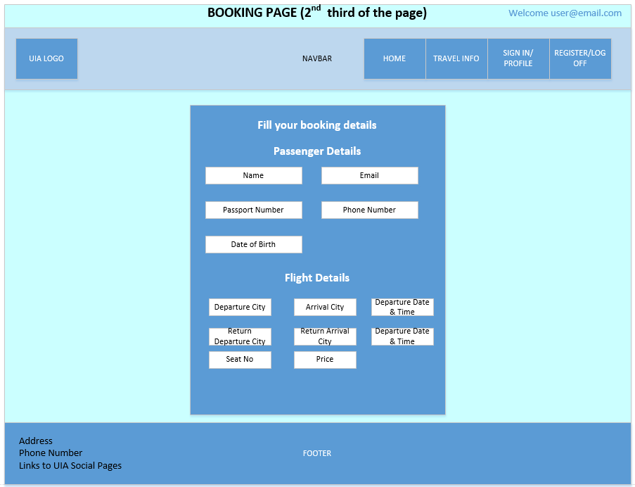

Figure . Booking Page Mockup (2/3)

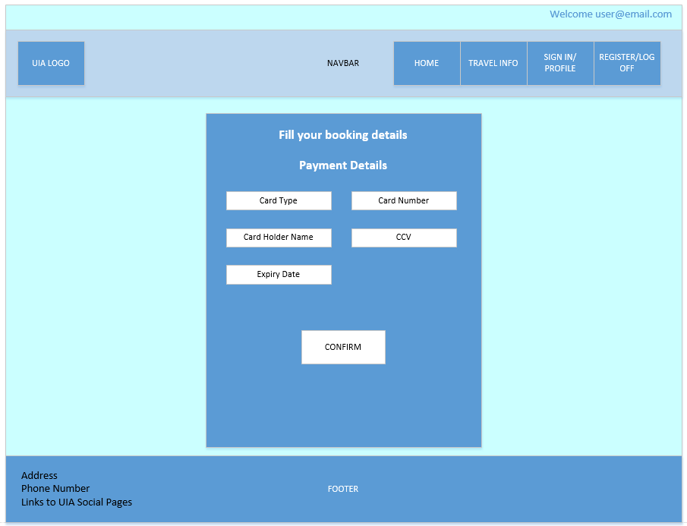

Figure . Booking Page Mockup (3/3)

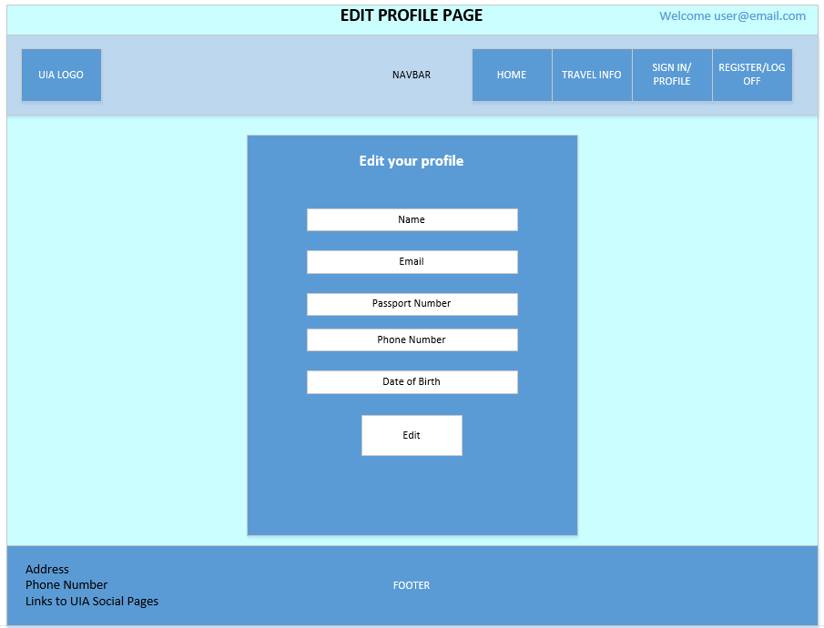

Figure . Edit Profile Page Mockup

## 3.3 Cloud Architecture Diagram

The architectural diagram below depicts the various elements that create the overall cloud architecture for this project. It includes two app services (UIA-SEA and UIA-West-EU) which hold the web applications and their associated service plans (S1). There are two Azure Storage blob containers, one holding the SQL auditing logs for security measurements, and the other the web configuration needed to implement the External Configuration Store Cloud Design Pattern. These are located within the same resource group as the Azure SQL Database, which contains the customer information. Furthermore, application insights was used to collect, analyze, and investigate both the performance metrics and failed requests (with raised exceptions) across the SEA web app. Lastly, the Traffic Manager has two registered endpoints, which are the aforementioned web applications, which have been enabled for continuous deployment through Git.

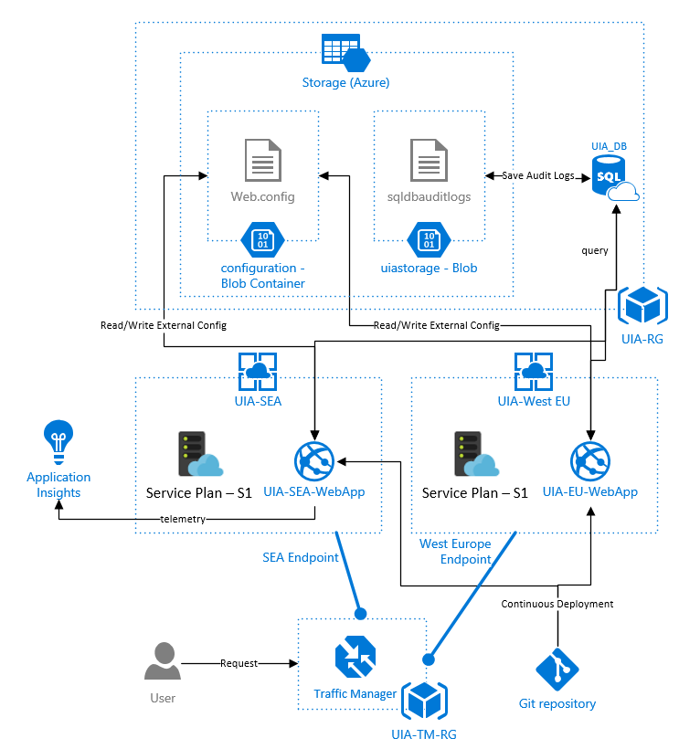

Figure . Proposed Cloud Architecture Diagram

# 4.0 Implementation

## 4.1 Core Application Implementation

### 4.1.1 External Configuration Store (Cloud Design Pattern)

Majority of web applications tend to embed their configuration information within the files that are deployed during the deployment phase. This often creates a hassle when changes occur to the configuration information. For instance, the migration of an SQL database from one server to another, which requires a change to the connection strings within all of the deployed web applications. External Configuration Store is a cloud design pattern that attempts to migrate the web configuration out of an application’s deployment package to a centralized location (Narumoto, et al., 2017). This provides an interface through which the configuration settings of the web applications can be quickly and efficiently read, updated, and managed. This pattern is often used in various scenarios that add towards its suitability of implementation for this project, which are:

* Configuration settings are shared between various web applications. For this project, as the web application is deployed in two regions, it is necessary to ensure that they have the same web configuration that stores the database connection strings.
* Simplify the administration of various web applications, as each web application’s configuration doesn’t need to be manually updated as changes occur to the configuration. For this project, during the development phase, the database was stored locally, therefore its connection string was pointing to a local database. As the SQL database got deployed to Azure, the connection string needed to be changed, therefore this pattern provided an easy and efficient transition between these two stages. Furthermore, if there is a change to the database, such as moving it to another server or changing it into an Azure Table Storage, this needs to be appropriately reflected within all the deployed web applications. The image below shows an overall illustration of this cloud design pattern.

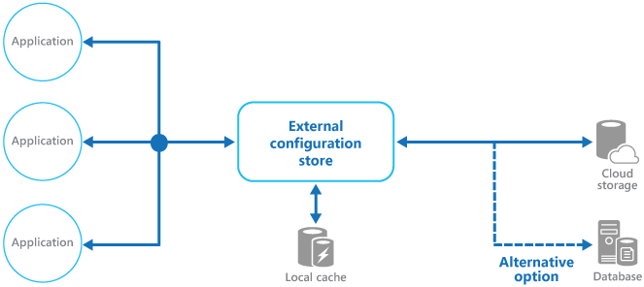

Figure . External Configuration Store Diagram (Narumoto, et al., 2017)

For this project, an Azure Blob Storage had been created that consisted of a container called “configuration”. This container held the web.config file from the web application, which was uploaded using the code snippet written below.

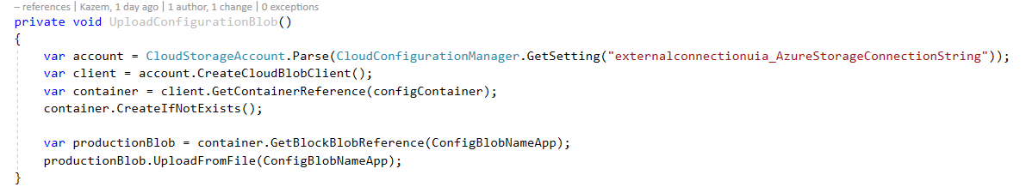

Figure . Upload Config Blob - Code Snippet

Each time the config checker is executed, the connection strings within the deployed web.config is updated to ensure that the latest connection strings are being utilized, as shown below.

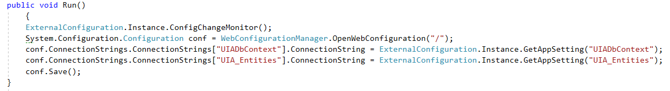

Figure . Config Checker Run - Code Snippet

### 4.1.2 Security and Authentication

A core concern revolving around the implementation and usage of web applications is the security and authentication necessary for the forms and view-state. To address this, Microsoft has developed ASP.NET Identity system to replace their membership and simple membership systems (Anderson, et al., 2017). This is uses 128-bit AES for the encryption, decryption, and validation of the forms-authentication and view-state data, which does not have any known practical attacks (Anderson, et al., 2017).

Several notable features of ASP.NET Identity have been implemented in this web project. Firstly, by utilizing the Anti-forgery token, which prevents Cross-site Request Forgery (CSRF) attacks, as shown below. For each form, an anti-forgery token is generated, and validated in the controller.

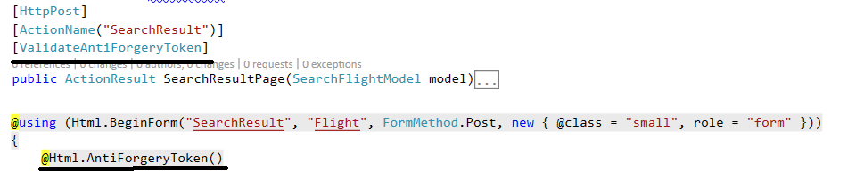

Figure . Anti-forgery token Generation and Validation in View and Controller

Additionally, it provides the Authorize and AllowAnonyous tags, which dictate the access to certain controllers based on the level of authentication. For instance, AllowAnonymous indicates that a controller is accessible without user-authentication, while authorize requires the user to be logged in and meet the authentication requirements, as shown below.

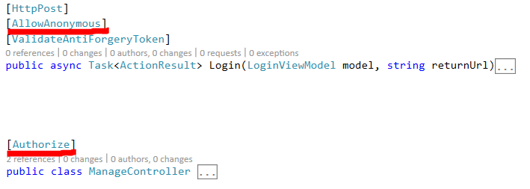

Figure . Authorize and AllowAnonymous Tags

Furthermore, it supports plugging new profile data, by providing full control over the schema for the user and profile information, such as allowing the users to store their passport number and date of birth while registering. For this project, the Entity Framework code-first approach was used to migrate the changes to the user profile (adding phone number, name, passport number, and date of birth). Lastly, by integrating OWIN (Open Web Interface for .NET), it allows for the cookie-based user authentication (log in/out), as shown below.

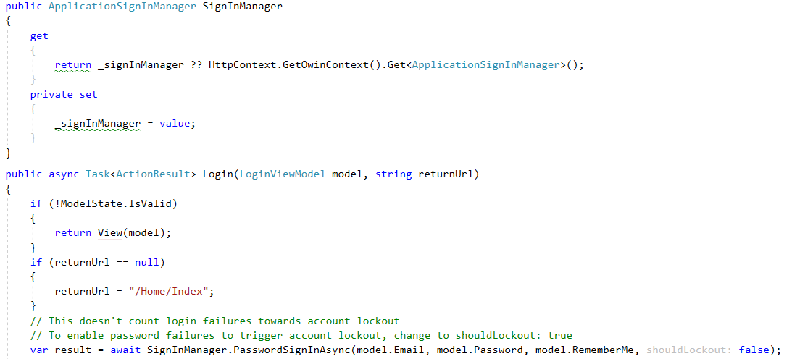

Figure . OWIN-based Authentication - ASP.NET Identity

### 4.1.3 Dynamic Seat Picker

A primary feature of most modern flight booking web applications are the ability to provide flexibility of use to the customer to improve the usability by allowing users to pick their seats in advance during the booking process. This is achievable in many ways; however, it should be tailored such that it can maximize the user experience and ease of use for users with varying mental models. To achieve this, a dynamic seat picker has been implemented using SVG and JavaScript from AnyChart, a flexible HTML-based solution provider for building interactive maps, including seat maps (AnyChart, 2017). It has been modified to allow the script to update the respective seat number fields after the customer has chosen a seat on the SVG image, as shown below.

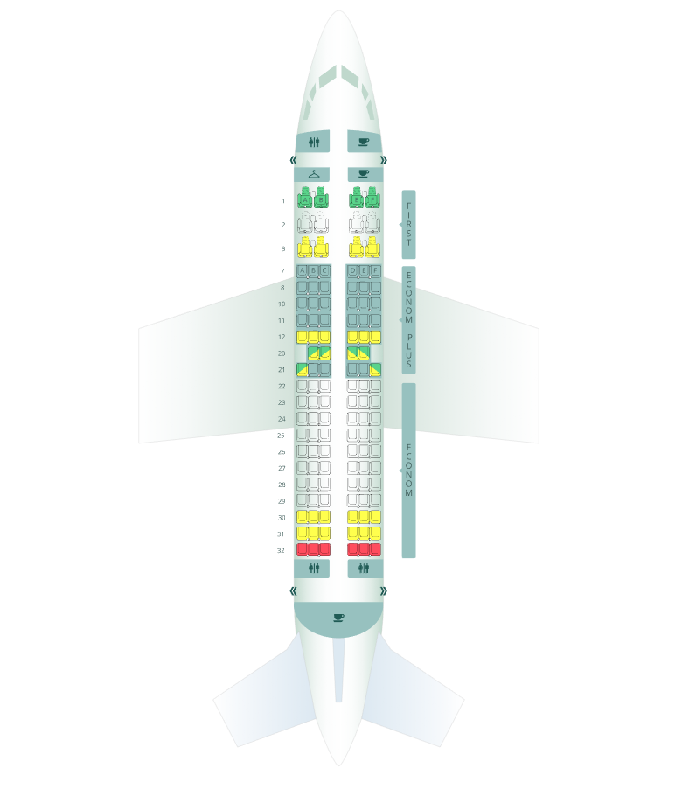

Figure . Boeing 737 SVG Seat Layout (AnyChart, 2017)

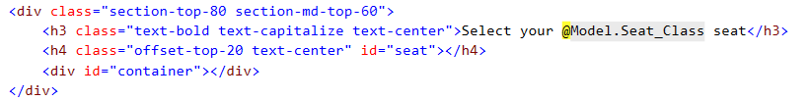

Figure . Div Tag to hold Seat SVG graph and Selected Seat - Code Snippet

The code snippet below describes the JavaScript that loads the SVG image within the container div tag.

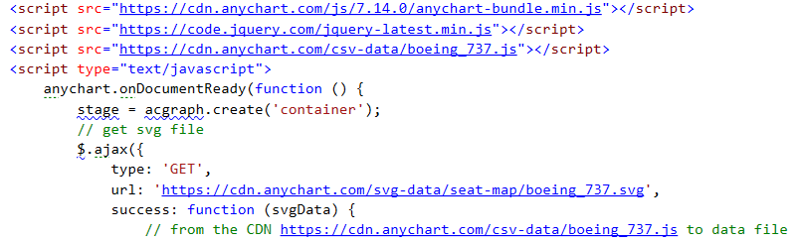

Figure . Generate and hold SVG graph – Code Snippet

The code below describes the action listener that updates the seat number field when the user selects a seat on the SVG image (pointsSelect function).

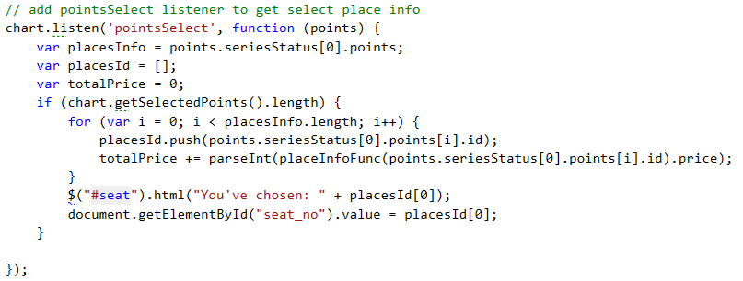

Figure . Update Selected Seat - Code Snippet

### 4.1.4 GeoIP-based Currency

An important aspect of consideration regarding the design and implementation of the web application is localization. As UIA provides international flights, this will naturally resonate into a business market that consists of customers from varying countries. One way to achieve localization, which will ultimately improve the user experience, is through the adaptation of varying currencies based on the customer location.

Web applications work through requests. A client sends a request, which within an MVC architecture will be passed into the controller as an HttpRequest object (LeBlanc, et al., 2017). This object has various server variables that can be used to identify the IP address of the user. The request headers can be spoofed or be left empty. Furthermore, many users might be behind a proxy server (Forsyth, 2010). These can alter the server variables (returning null or wrong IP address). This falls out of the context of the implementation, as it defeats the purpose of localization as the users do not wish to expose their actual public IP address. Either way, the IPv4 address can either be detected through the REMOTE_ADDR element or UserHostAddress attribute, as shown below.

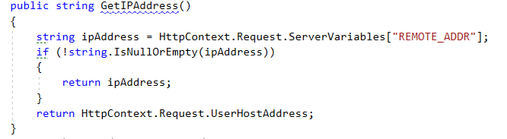

Figure . User IP Address (v4) based on Request variables

After attaining the user’s IP address, the location of an endpoint can be detected based on the IP address by querying a GeoIP database, such as MaxMind’s GeoIP databases. However, as these often require the databases (free or paid) to be locally stored and queried, it is easier to query through an API that provides free GeoIP services, such as freegeoip.net, which provides up to 15,000 queries per hour from a single host. It provides the ability to parse a receiving response stream into a JSON object that holds all the different key/value pairs for the geographic location of the submitted IP address (Fiori, 2017), as shown below. However, we are mainly considered with the country_code and country_name attributes, which for instance would return “MY” and “Malaysia” for an IP address originating from Malaysia, respectively.

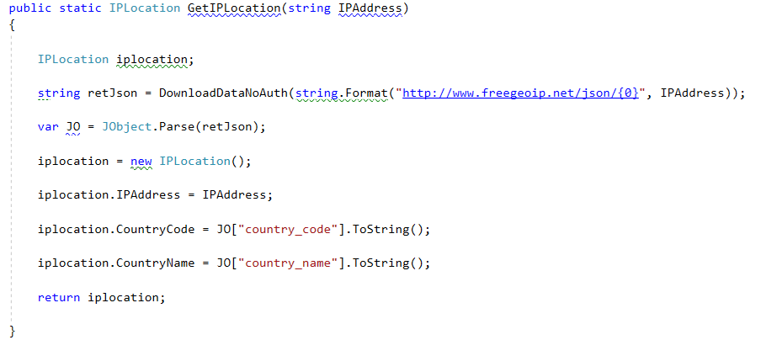

Figure . GetIPLocation - Code Snippet

Once the country code has been extracted, it can be compared to the varying country codes and the corresponding currency can be shown. The current implementation only supports Euro for majority of the European nations, Malaysian Ringgit for Malaysia, otherwise American Dollars is used, as shown below.

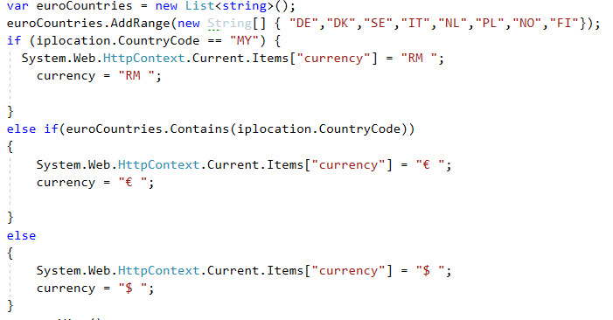

Figure . Currency based on IP - Code Snippet

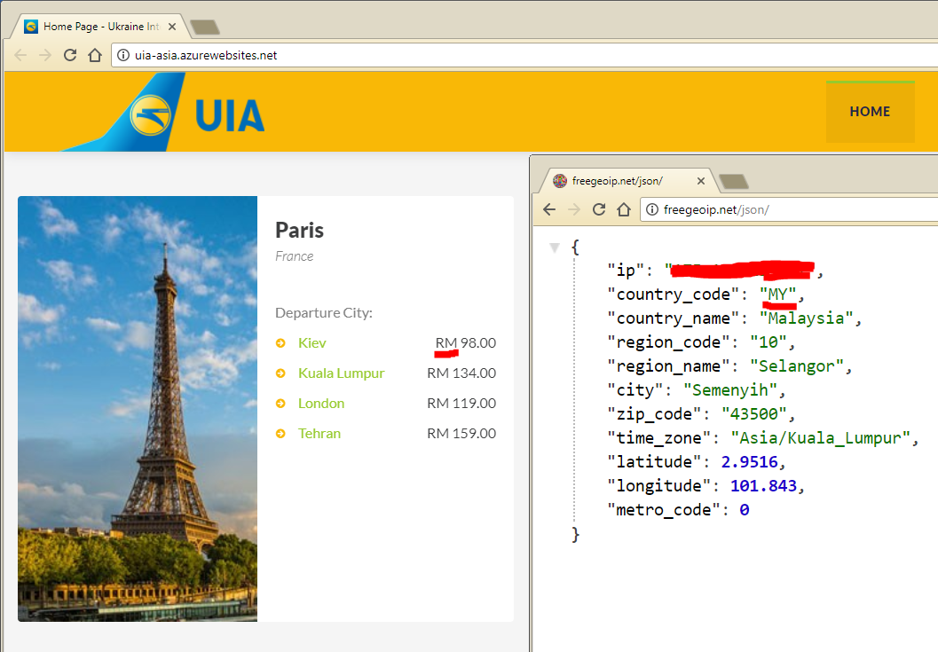

Figure . User Request from Malaysia - Ringgit Currency

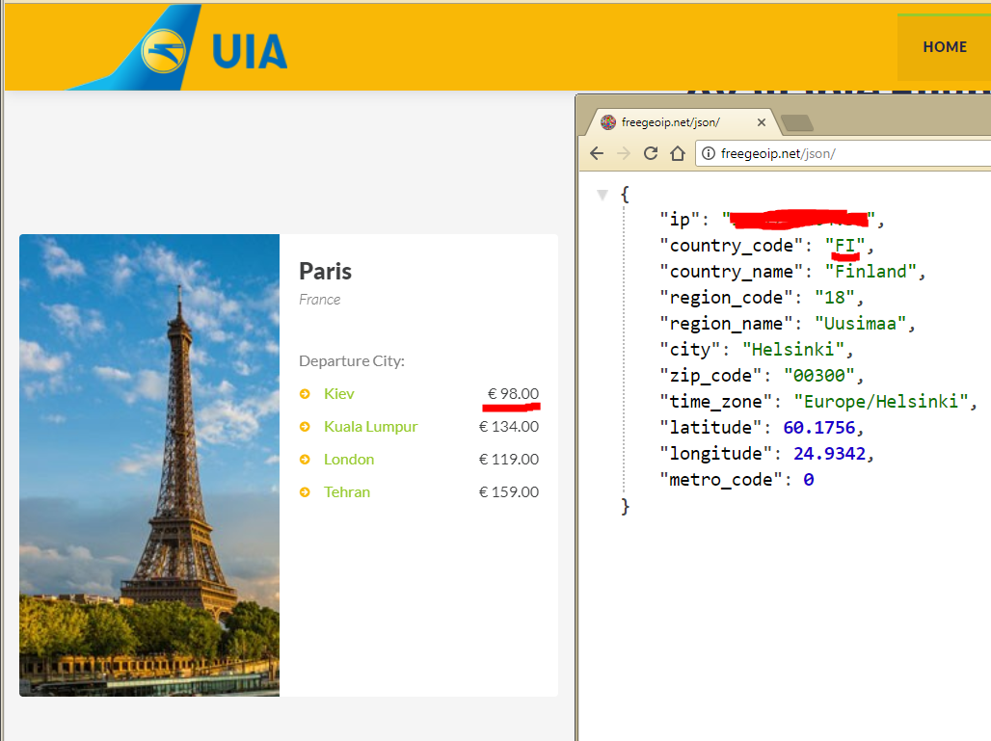

Figure . User Request from Finland - Euro Currency

It is important to note that the current implementation does not take into consideration the currency value-conversion, as it is outside the scope of the current project.

### 4.1.5 Developed Web Pages

The design of the developed web pages were based on a web template. The images below illustrate the various implemented web page designs.

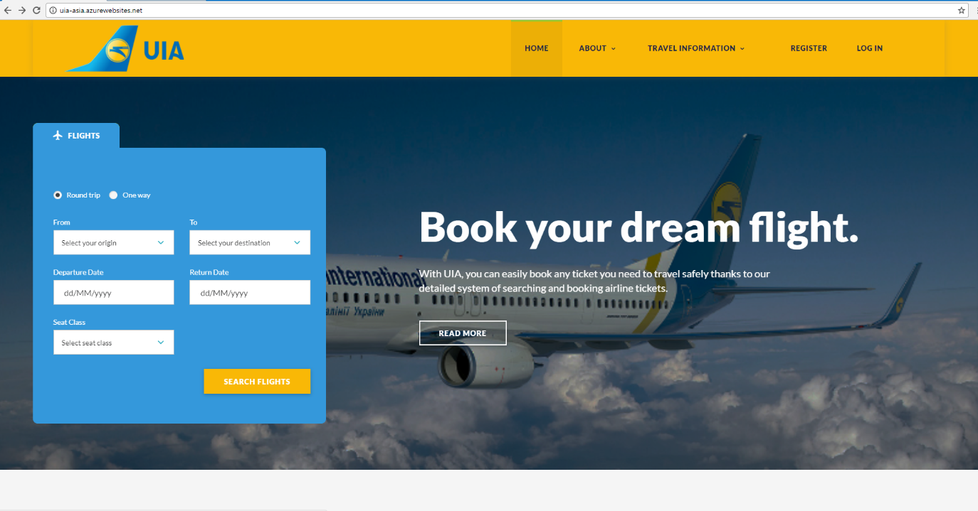

Figure . Homepage Implemented Design

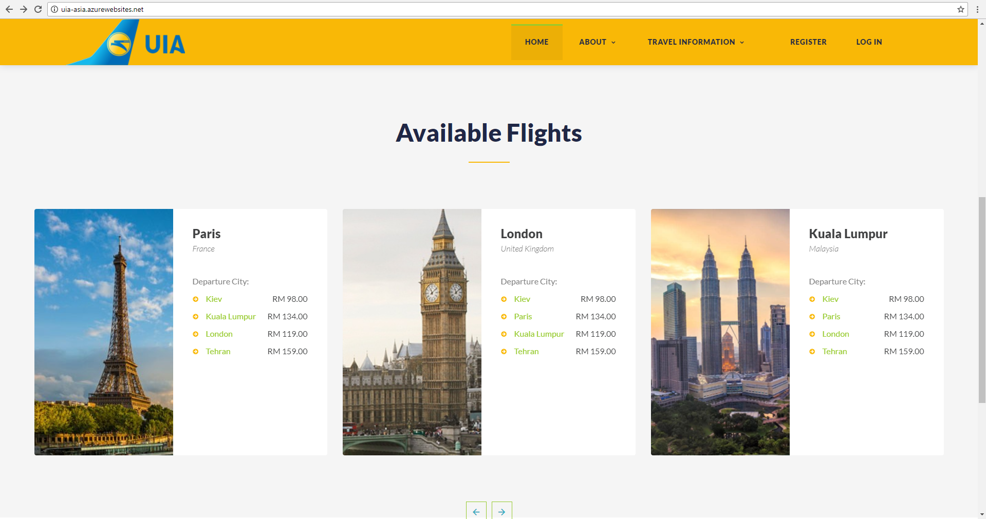

Figure . Available Flights Implemented Design

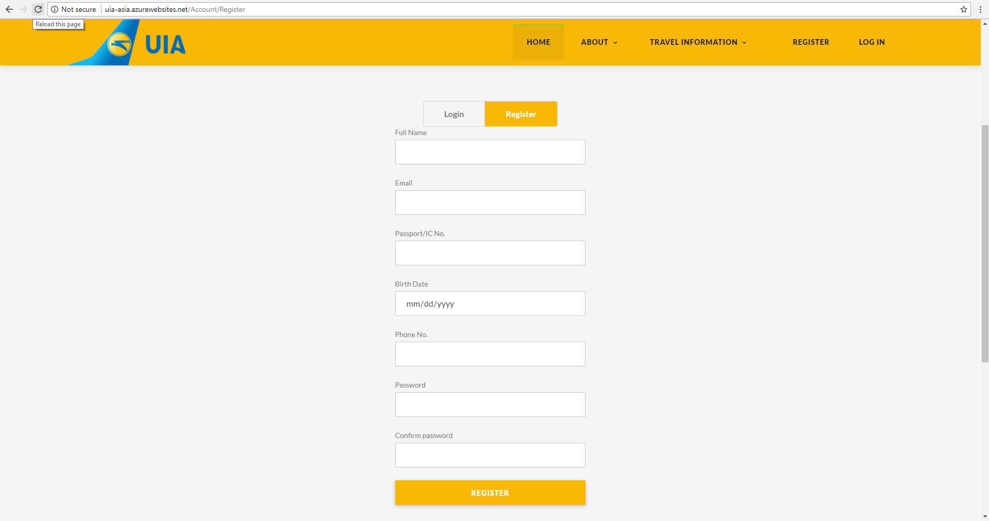

Figure . Register Page Implemented Design

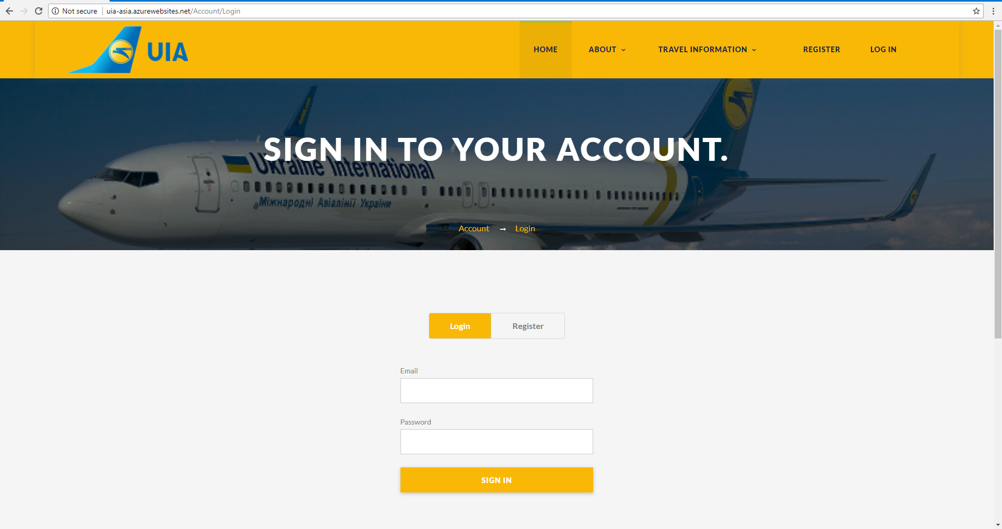

Figure . Login Page Implemented Design

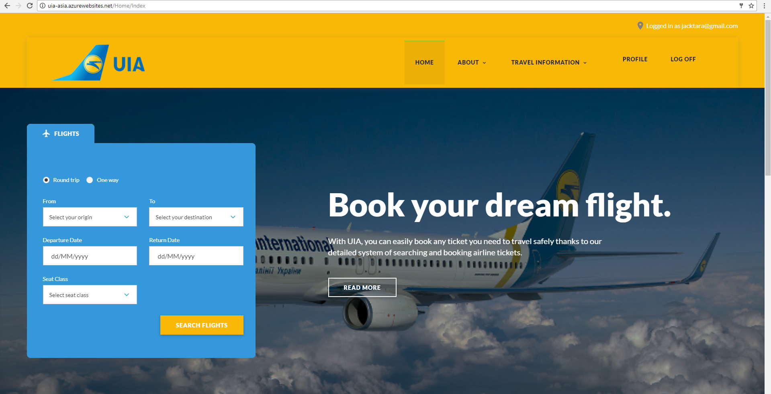

Figure . Homepage with logged in user

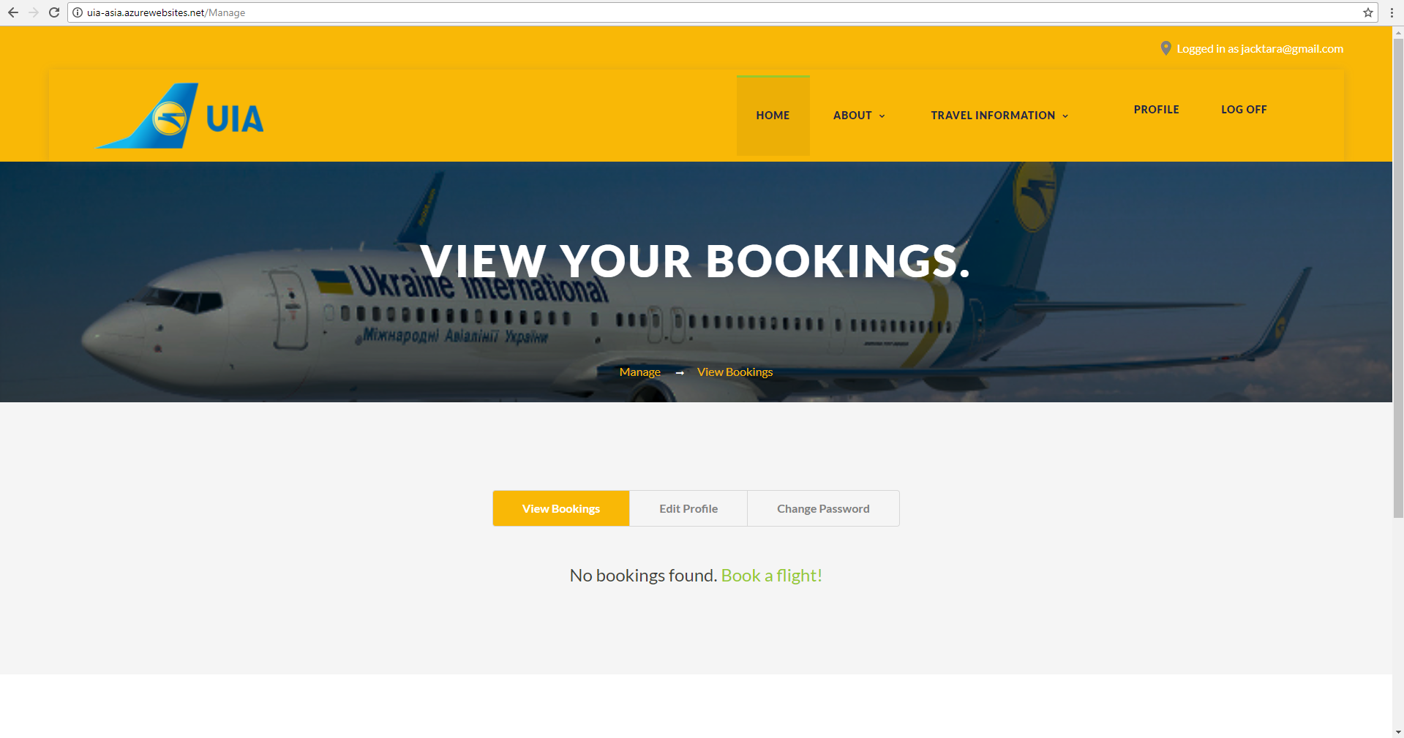

Figure . View Bookings Implemented Design - No bookings

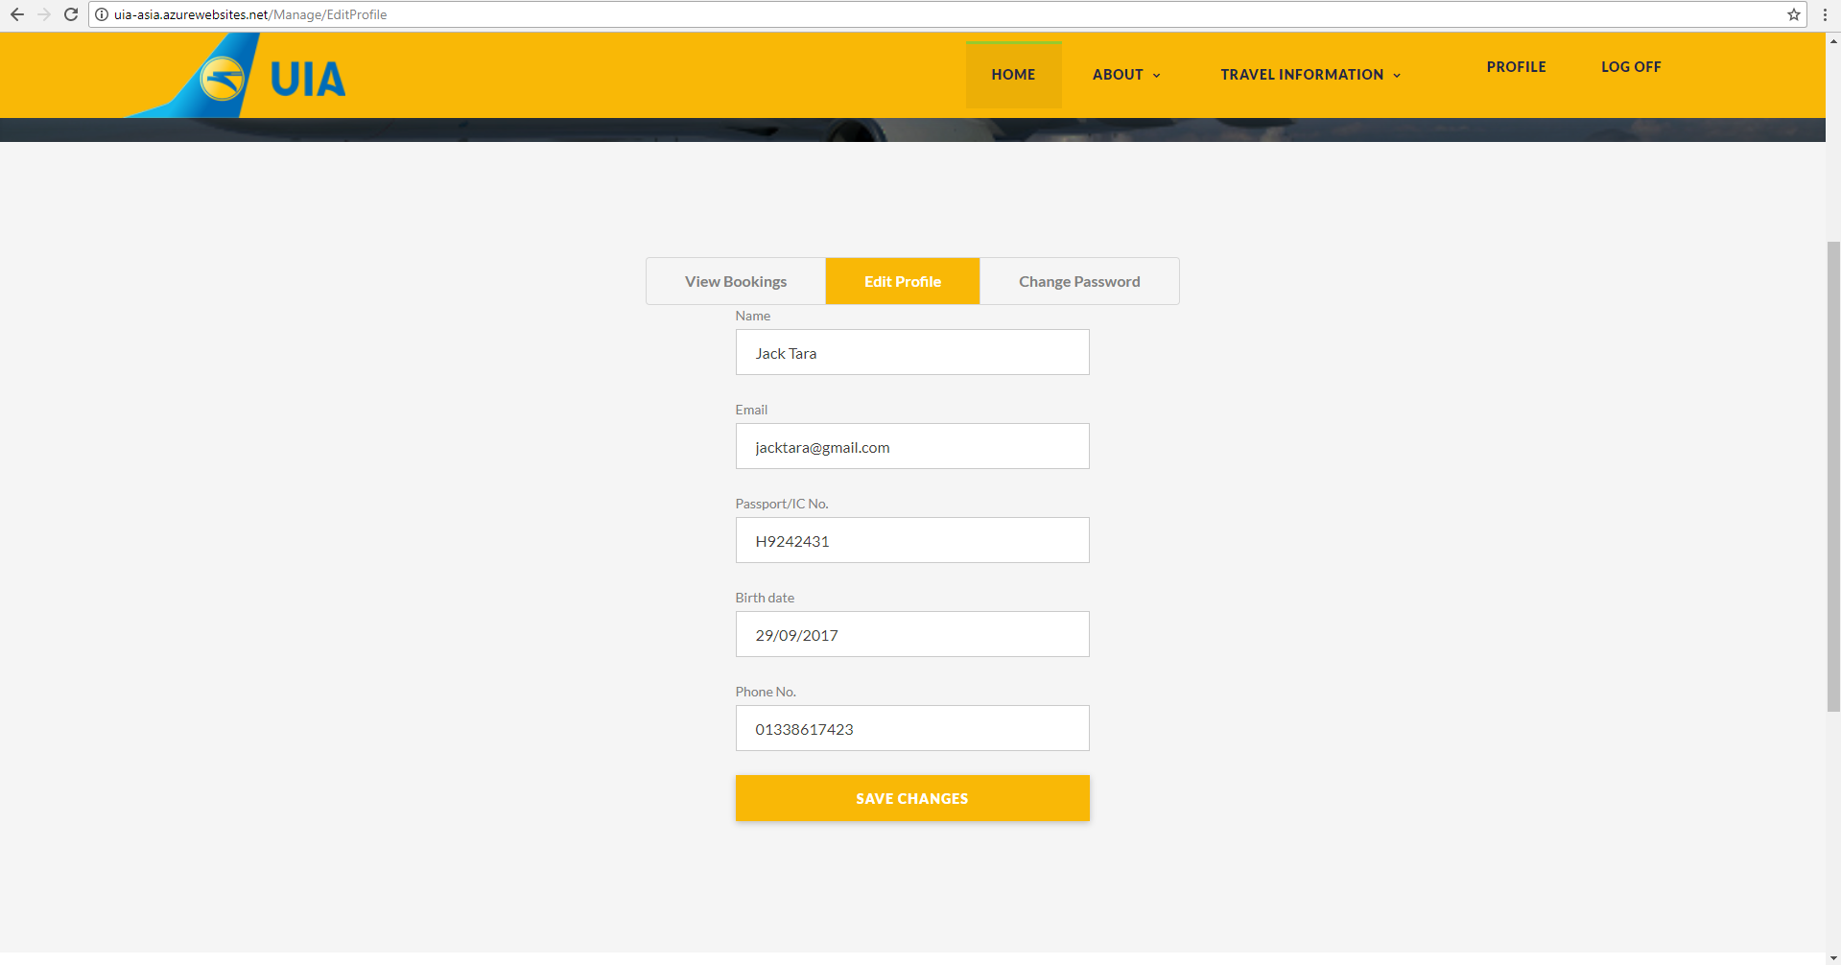

Figure . Edit Profile Implemented Design

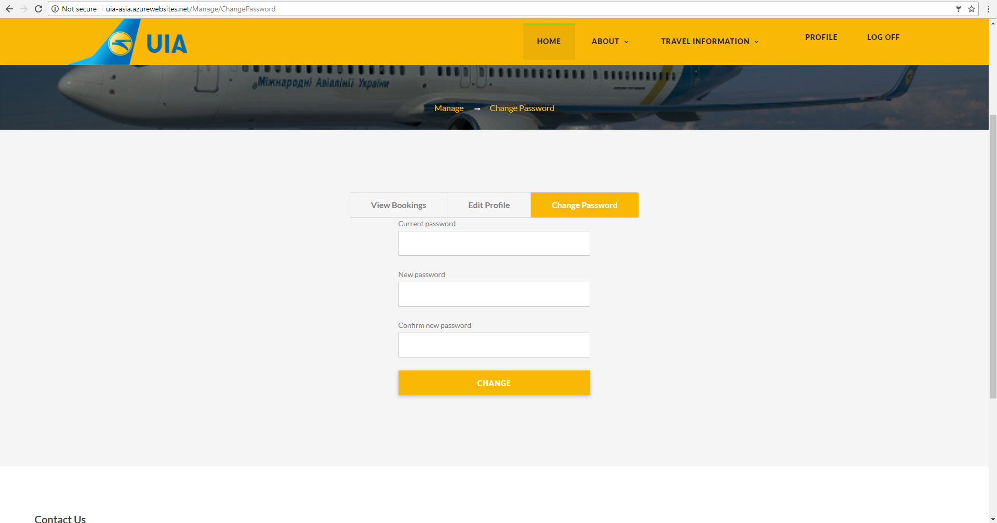

Figure . Change Password Implemented Design - Profile

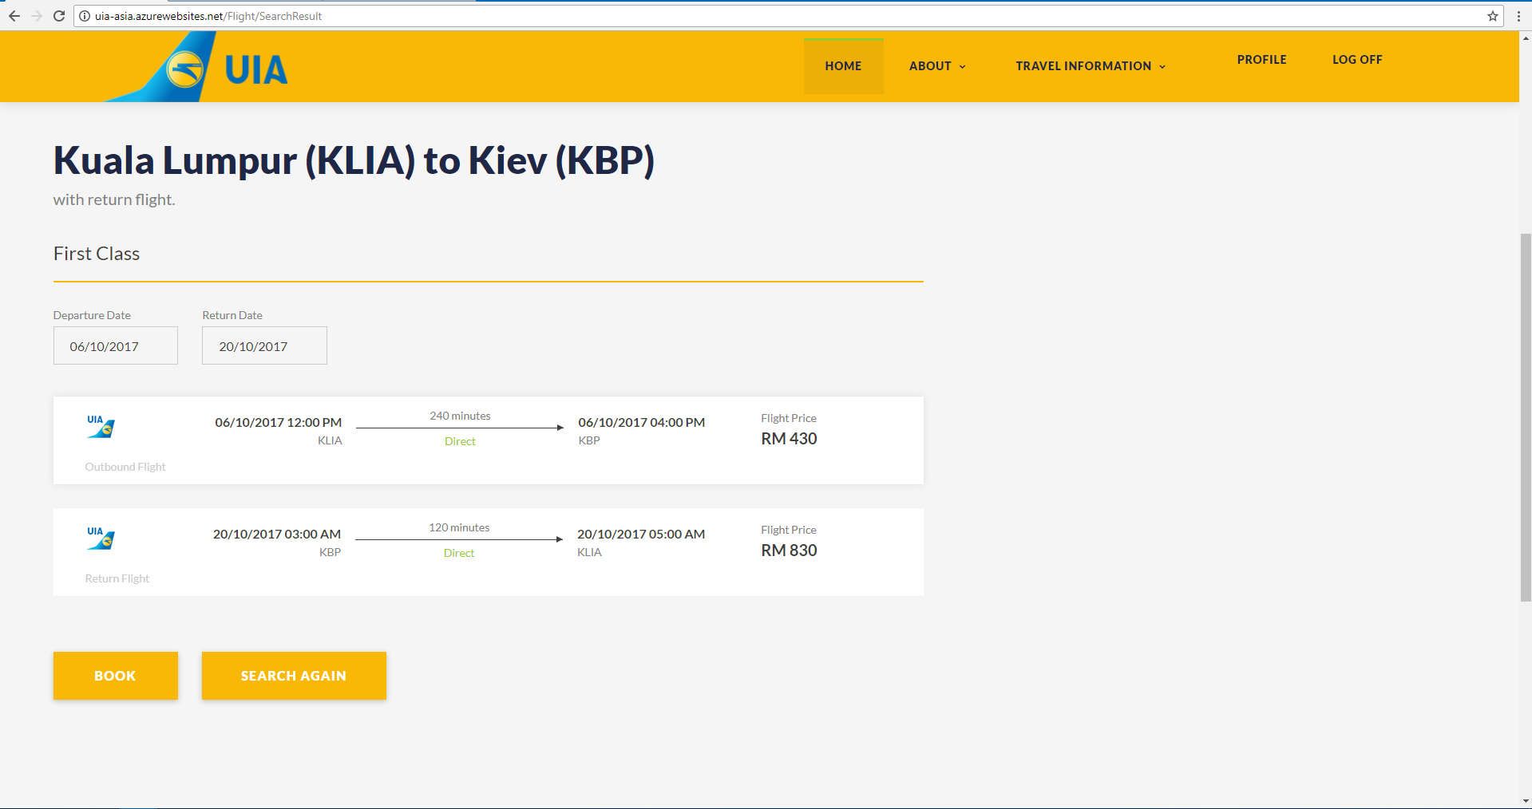

Figure . Search Result Page - Implemented Design

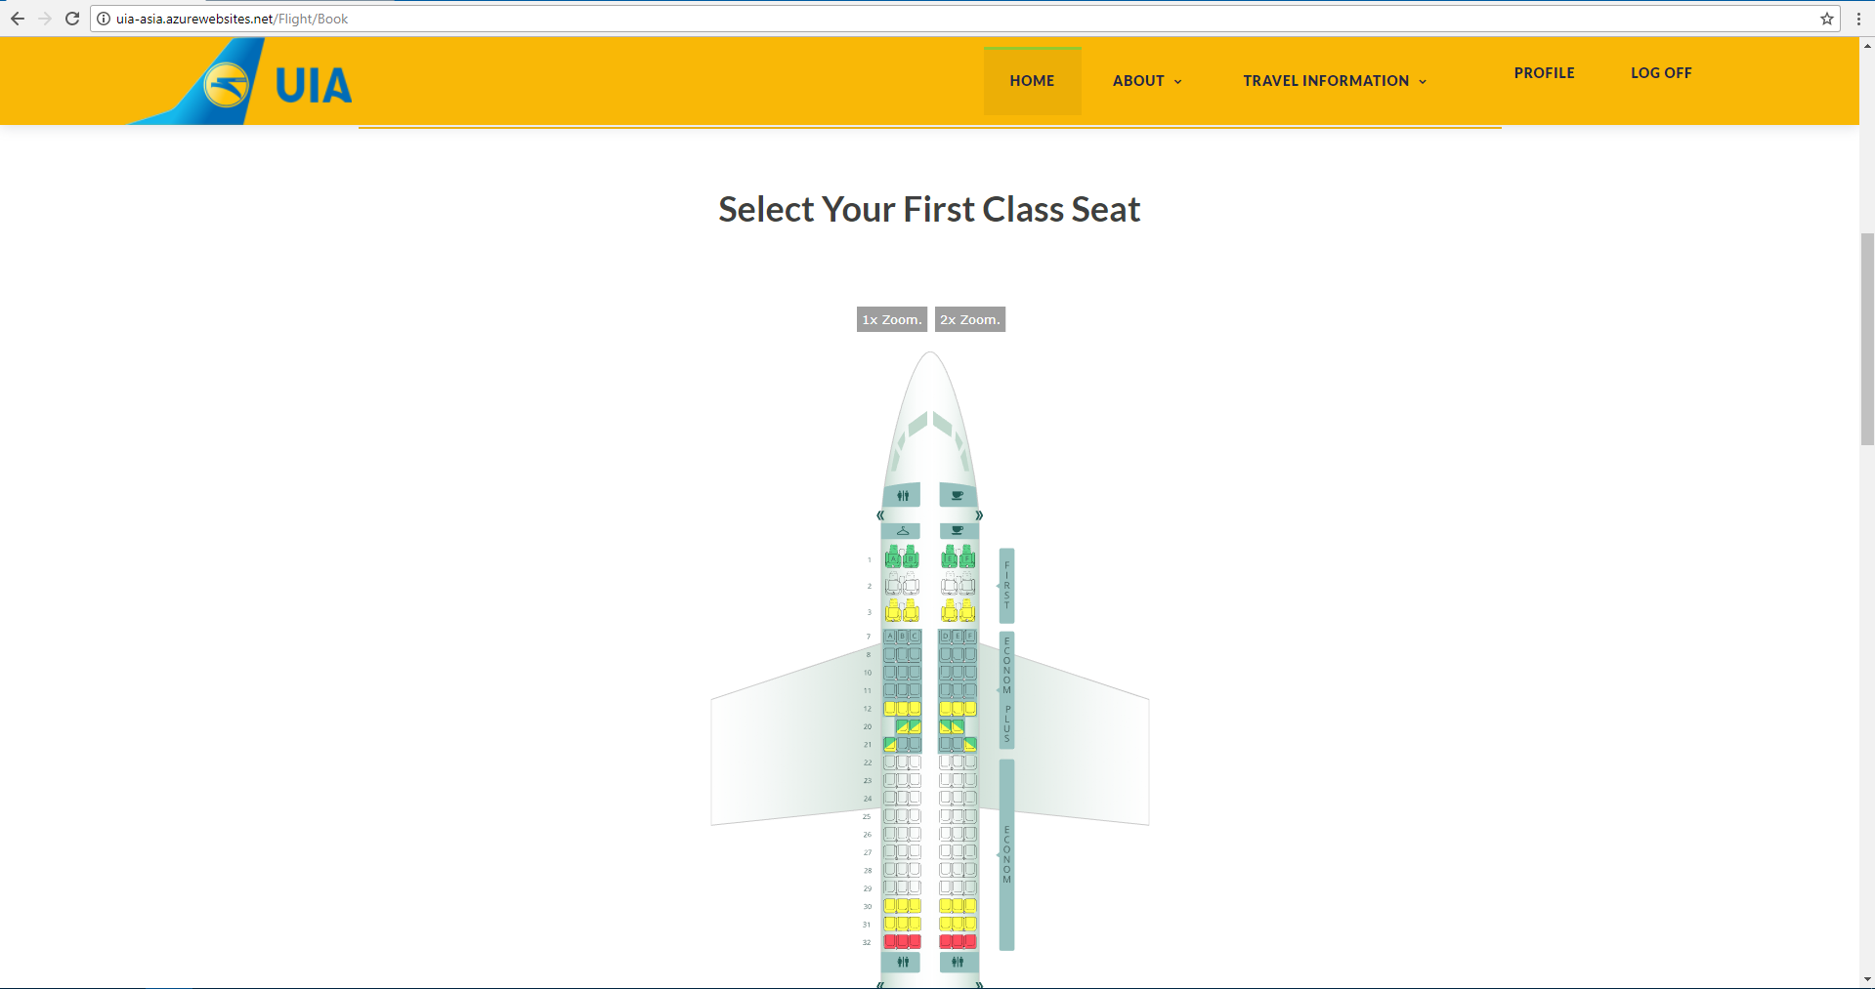

Figure . Book Flight Ticket Implemented Design - Part 1

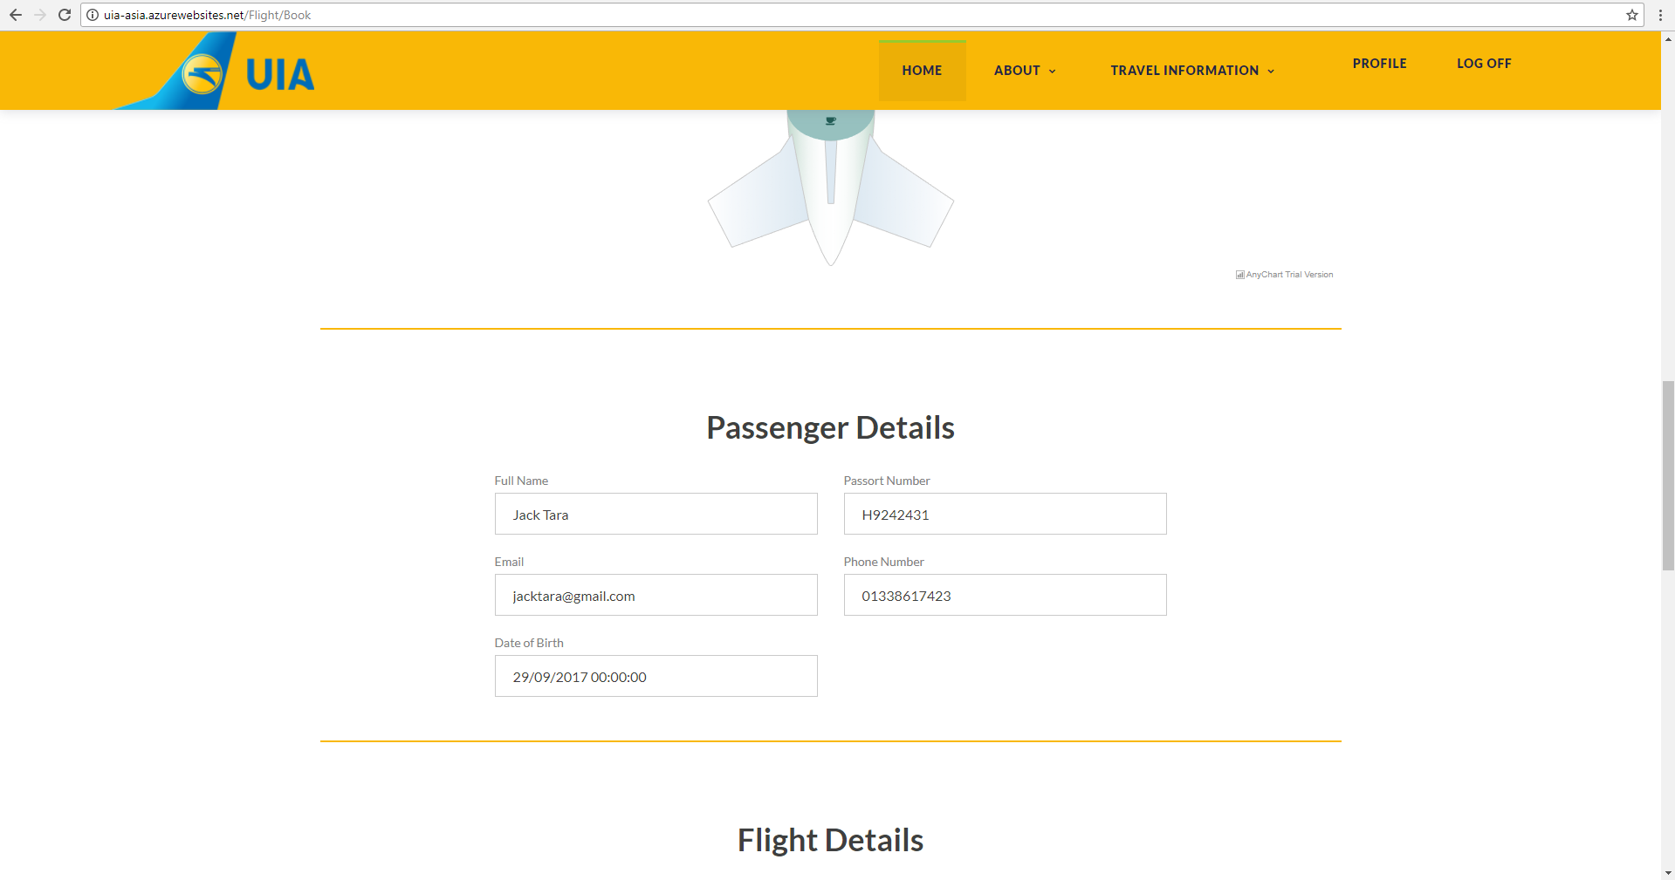

Figure . Book Flight Ticket Implemented Design - Part 2

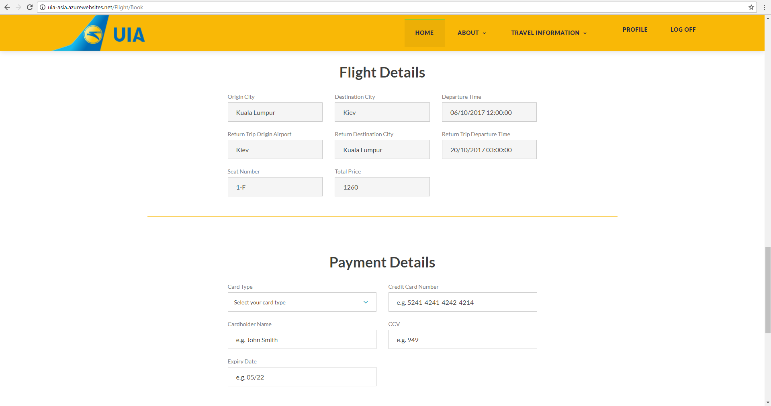

Figure . Book Flight Ticket Implemented Design - Part 3

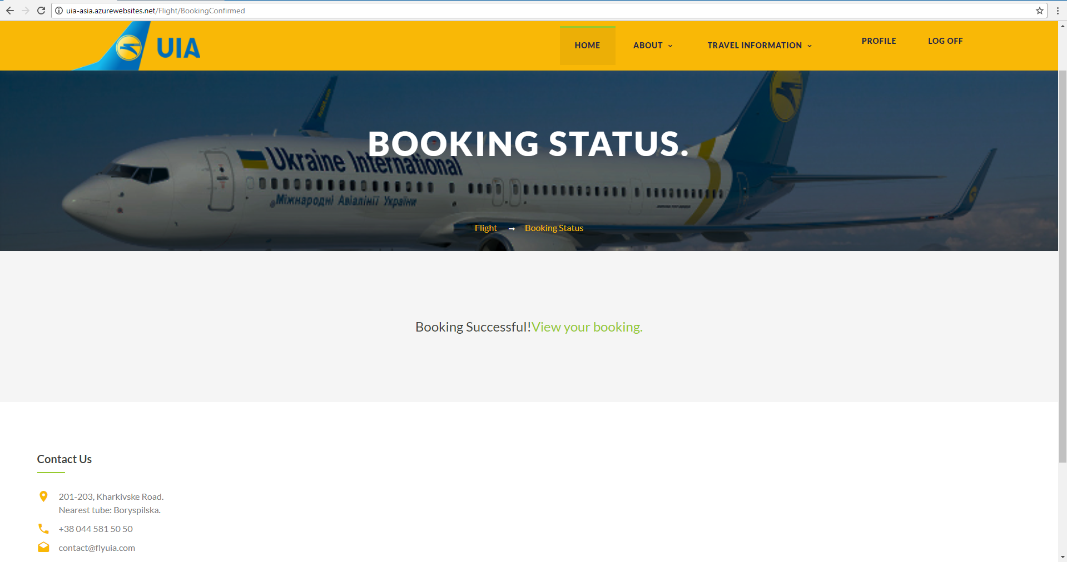

Figure . Booking Confirmed Page

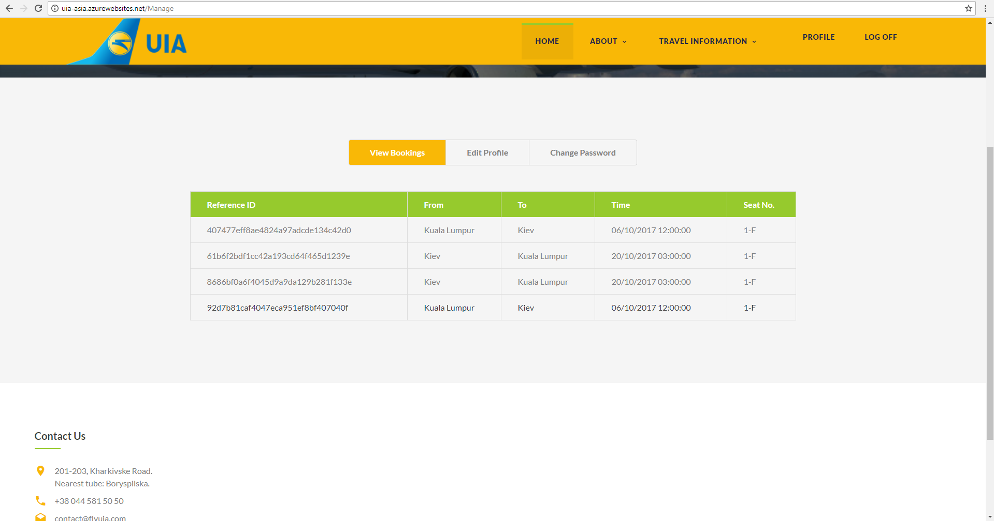

Figure . View Bookings Implemented Design

## 4.2 Cloud Implementation and Deployment

### 4.2.1 Cost Breakdown

The project is developed under the Visual Studio Dev Essentials package in Microsoft Azure, which provides RM 150 per month to be utilized. Therefore, it is important to identify the necessary resources and optimize the utilization of the resources to ensure that as much necessary features can be implemented within the limited monetary constraint. There are several core essential resources that have been identified, which are necessary for the project based on the set deliverables, which are:

* Web App (with its associated service plan)
* Azure SQL Database
* Azure Blob Storage
* Traffic Manager

Microsoft provides a price calculator for the provided Azure resources based on the needs. The cost has been broken down and analyzed using this tool. The figures below show the cost breakdown of each of the necessary resource groups based on the needs and chosen plans, the justification of which, will be discussed in the subsequent subsections.

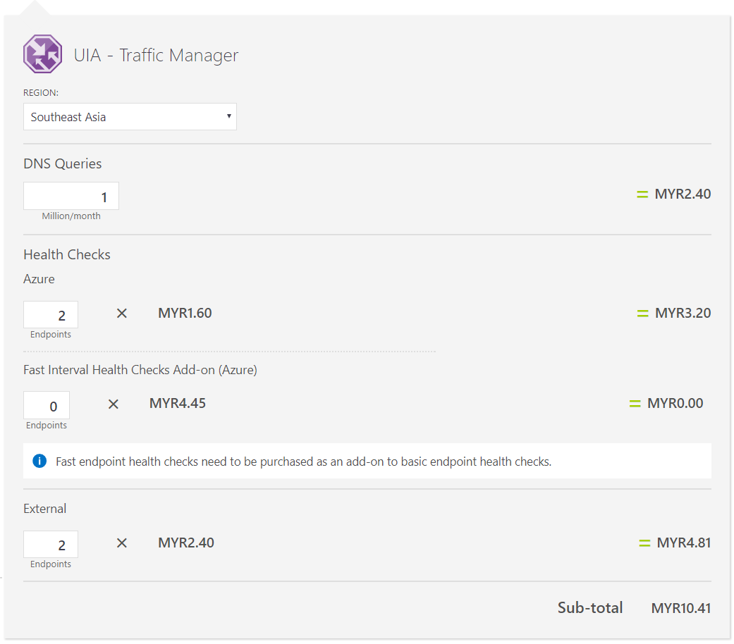

Figure . Traffic Manager - Cost Breakdown

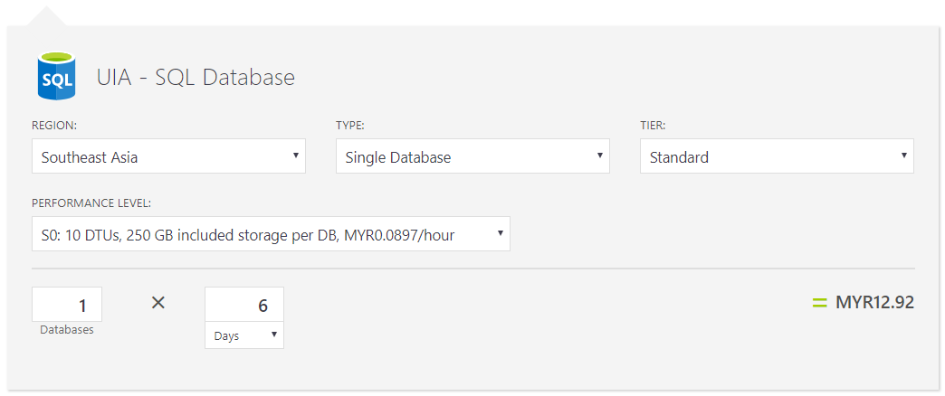

Figure . Azure SQL Database - Cost Breakdown

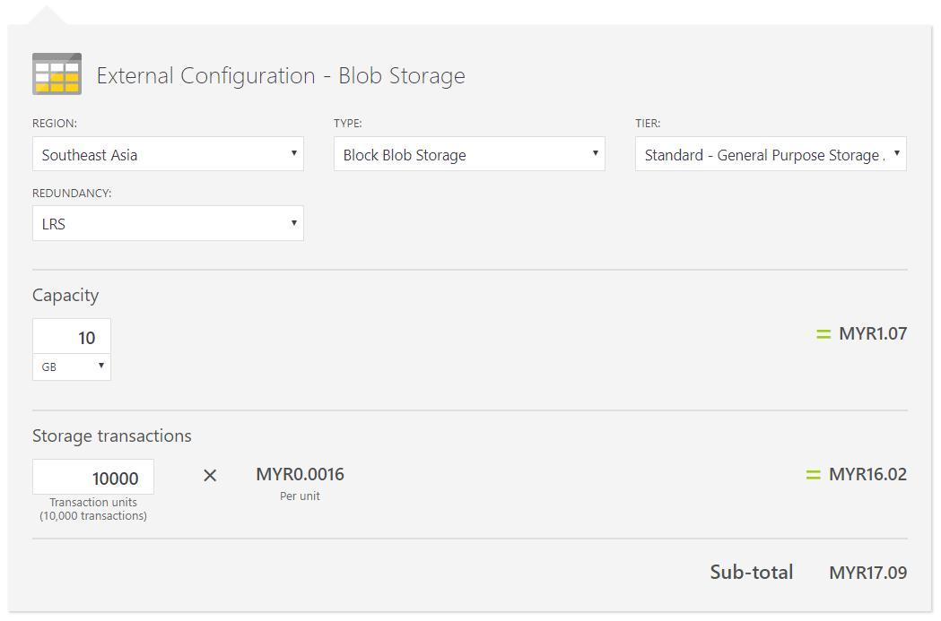

Figure . Blob Storage - Cost Breakdown

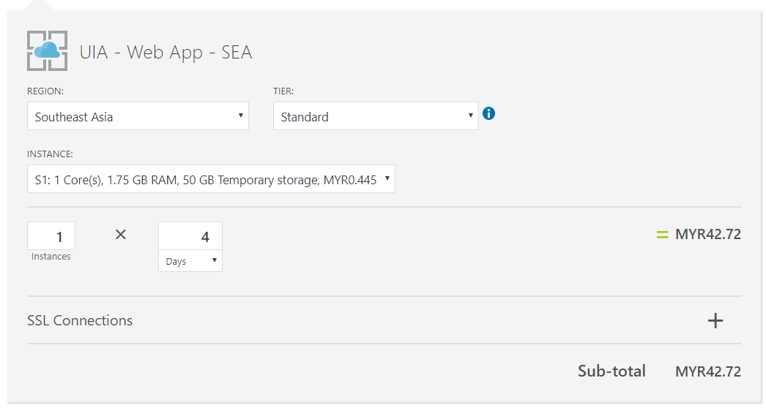

Figure . Web Application S1 - Cost Breakdown

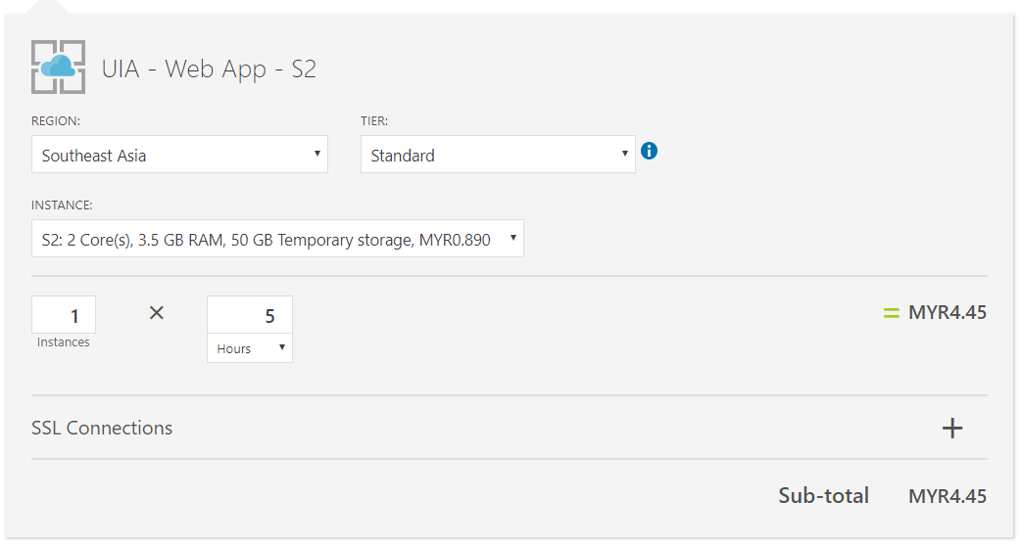

Figure . Web Application S2 - Cost Breakdown

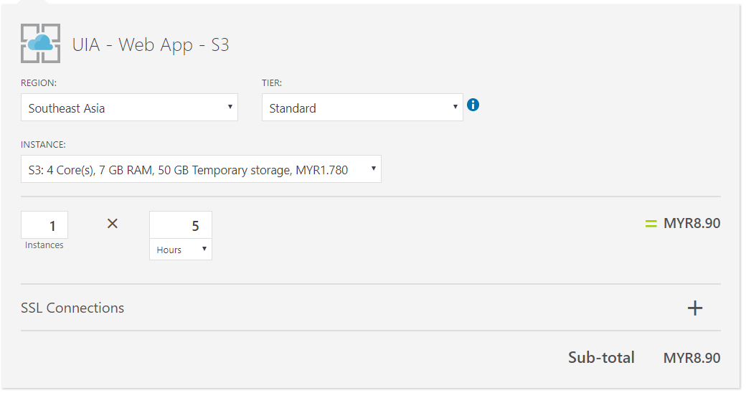

Figure . Web Application S3 - Cost Breakdown

The traffic manager’s calculation was based off the two endpoints that will be deployed and the minimum 1 million query/month, which is sufficient to cover the needs. Additionally, the Azure SQL database was set at S0 (10 DTUs) for a duration of 6 days, which provides sufficient time to migrate the database to the cloud prior to the deployment of the web applications and throughout the duration of the deployment. Furthermore, the blob storage necessary to implement the external configuration store cloud design pattern was set for 10,000 transactions, as there is a constant remote dependency on the configuration container that will be hosted, while the storage is set at the bare minimum, as the web configuration is generally very small in size.

Lastly, the web applications, which account towards the majority of the cost have been analyzed in terms of pricing for several things. Firstly, the cost has been calculated for the S1 tier for a duration of 4 days, which provides sufficient time to perform all the necessary actions (such as performance testing, documentation, and video demonstration) for the web application. Secondly, the cost of S2 has been calculated for a duration of 5 hours, which is necessary, as the app will be scaled-up as part of the performance testing strategy, and lastly the same cost has been calculated for the S3 tier, which is also needed as part of the performance testing strategy. Therefore, the overall cost falls just below RM 140 and can be covered under the Visual Studio Dev Essentials package.

### 4.2.2 Web App

Microsoft Azure provides the ability to develop and deploy cloud-enabled web applications through its Platform as a Service (PaaS). For this project, the developed web application will be published and deployed in two separate regions, namely Southeast Asia, and West Europe. Southeast Asia is chosen as the primary region for the web application as the development team is located in this region, and furthermore UIA is planning to extend their business network to the Asia Pacific region. Secondly, West Europe is chosen as the second region, as UIA’s headquarter operates in Ukraine, and mostly in Europe. That is the closest endpoint to Ukraine as there are no data centers in Russia due to political and security stability influx. The standard tier is chosen as the service plan for both the web apps, as it is the lowest tier required to implement the traffic manager, which is another necessary resource required for achieving the deliverables. The prices within this tier double as you move across the levels (S1, S2, S3), and S1 is deemed suitable as it falls within the budget, while providing geo-availability through the utilization of a traffic manager.

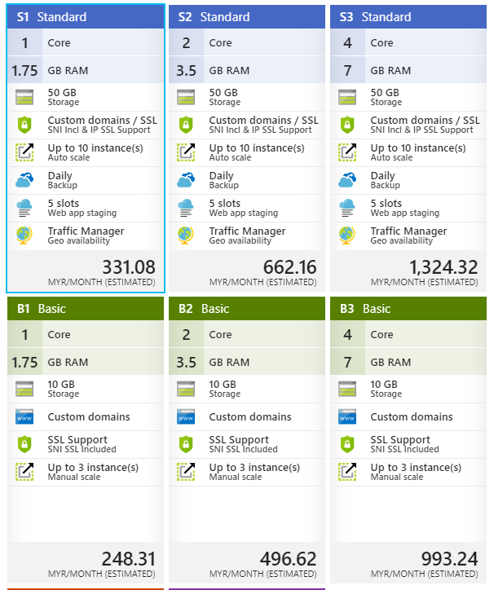

Figure . Basic vs Standard Pricing Tier

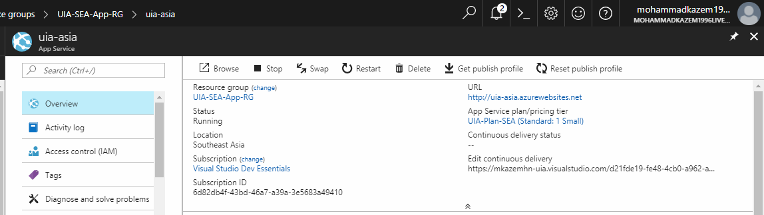

Figure . SEA-deployed Web App

The figure below shows the app service plan, URL, and location of the second deployed web app, which is located in West Europe.

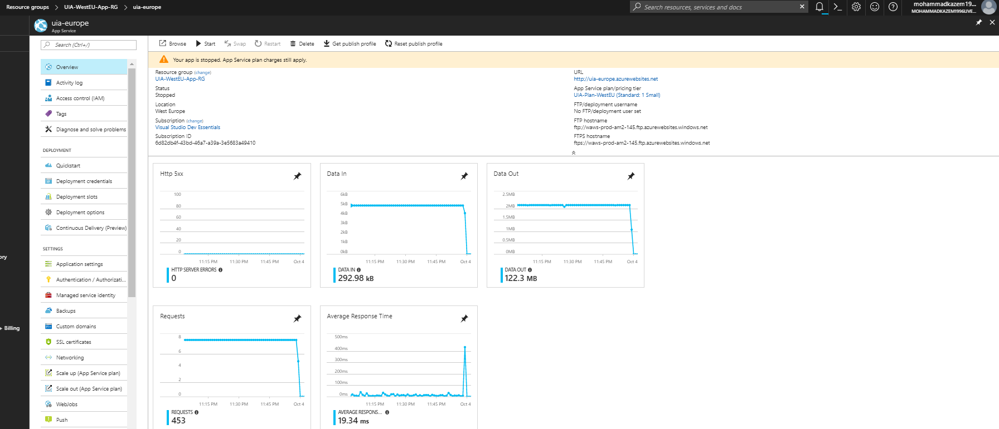



Figure . West Europe Web App

For the success of a web application, it is essential to bring about continuous changes that enhance the user experience. However, there are many bottlenecks associated with the manual deployment of a web application to Azure. As the number of endpoints increase, it becomes increasingly difficult to continuously push the latest changes to the live version. Microsoft Azure has introduced an option that is currently in the preview form, called continuous deployment, which allows for the continuous synchronization of the deployed web applications through pulling committed changes from a GitHub repository, as shown below.

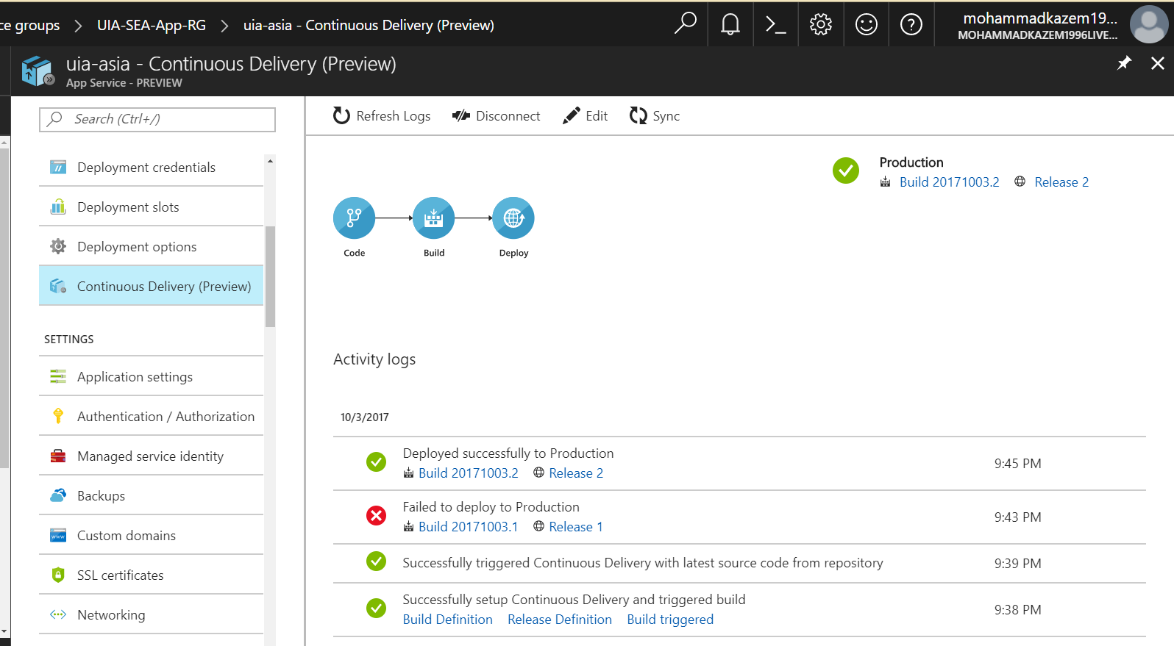

Figure . Continuous Deployment on Azure Web App

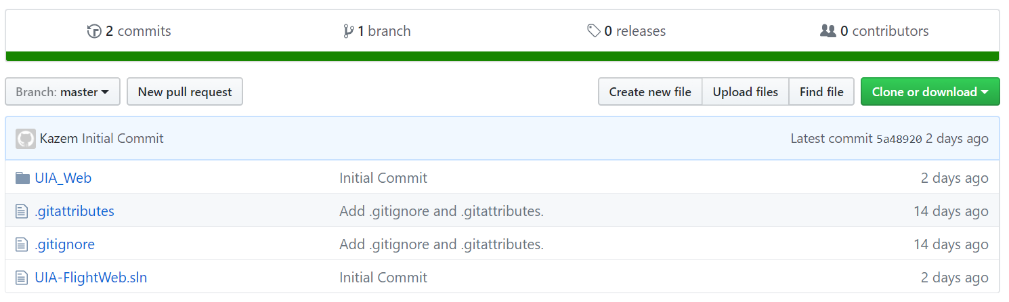

Figure . GitHub Repository

One of the prioritized deliverables of this project is to be able to handle high demand during peak seasons that plays into the performance and scalability quality attributes of the system. In order to address this, web applications usually scale either horizontally (scale out/in) or vertically (scale up/down). For this project, the deployed web applications have bene configured to scale-out by adding a second instance of the same service tier to assist in the handling of increased load that can be detected through a set rule that is defined as an increase of over 90% to the CPU usage for the current instance, as shown below. However, it is also important to scale-in whenever the web application is idle and there is no longer a high demand that requires additional resources. Therefore, the instance count decreases to 1 when the average CPU usage is below 30%, as shown below.

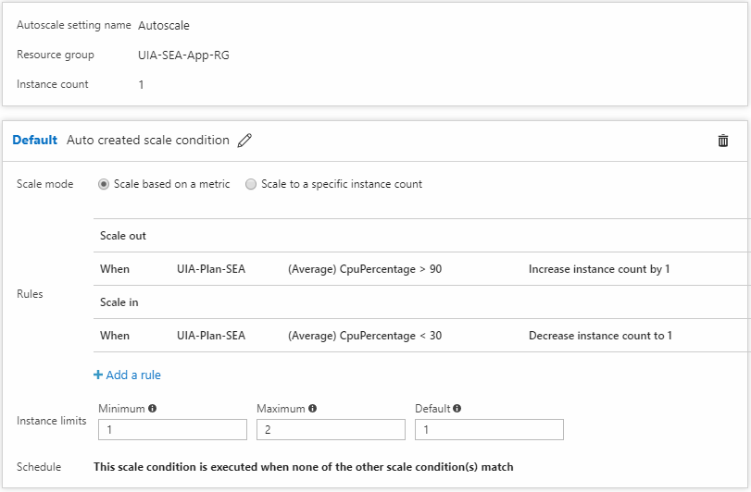

Figure . Scale-out during high demand

### 4.2.3 Azure SQL Database

Flight booking web applications are hugely data-driven. This indicates the need for a database which is mainly reliable and secure. Furthermore, it is important to implement a solution that will provide seamless update and patches necessary to the SQL code base, and remove the unnecessary constraints set by managing the underlying infrastructure. Azure SQL Database can provide a high-level solution for this as a service through managed databases that are dynamically scalable with high-performance (Rabeler, et al., 2017).

By utilizing SQL database as a service, the database is isolated and a certain level of performance is guaranteed as governed by the chosen service tier. There are four service tiers provided for an Azure SQL database, namely basic, standard, premium, and premiumRS (Rabeler, et al., 2017). The table below compares the varying service tiers provided for an Azure SQL database.

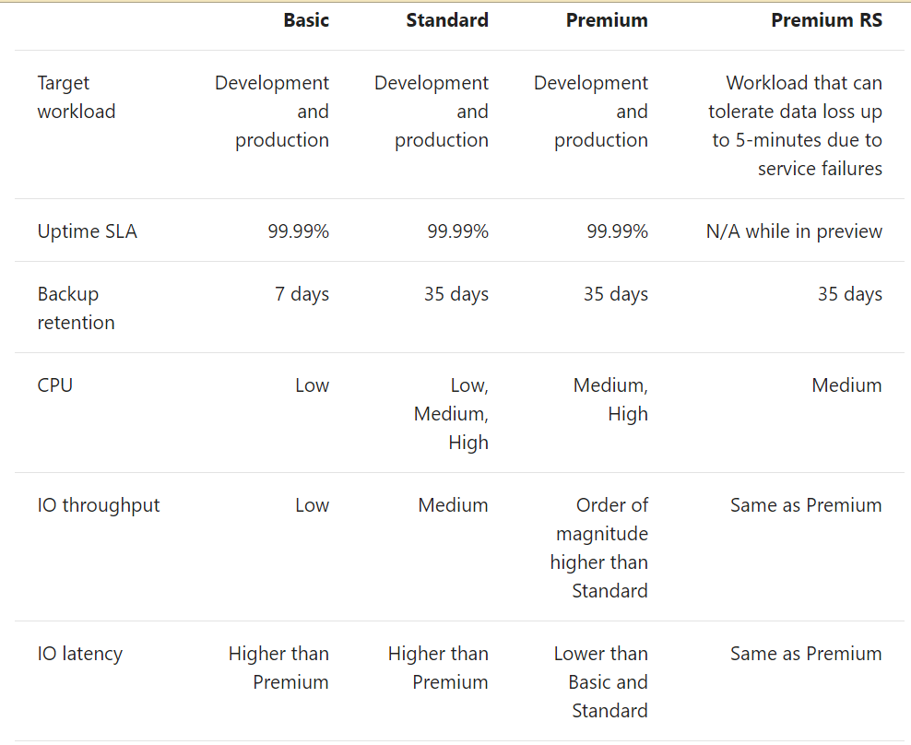

Figure . SQL Database Service Tier Comparison (Rabeler, et al., 2017)

The service tier chosen for this project’s Azure SQL database is **standard**. As mentioned previously, web applications such as this are data-driven, therefore it is inherent that the I/O operations will be high with increased memory and CPU usage within the hosted server, which is defined as Database Transaction Units (DTU) by Azure. Basic provides the lowest DTU (low CPU, I/O throughput, and increased latency), which voids its appropriateness for this project, while premium and premium RS cannot be financially justified within the budget even though they provide the highest DTUs possible, therefore they are ommitted, thus standard is the most optimal. The number of DTUs chosen for the standard tier is 10, which sets it as S0, with a storage size of 250GB.

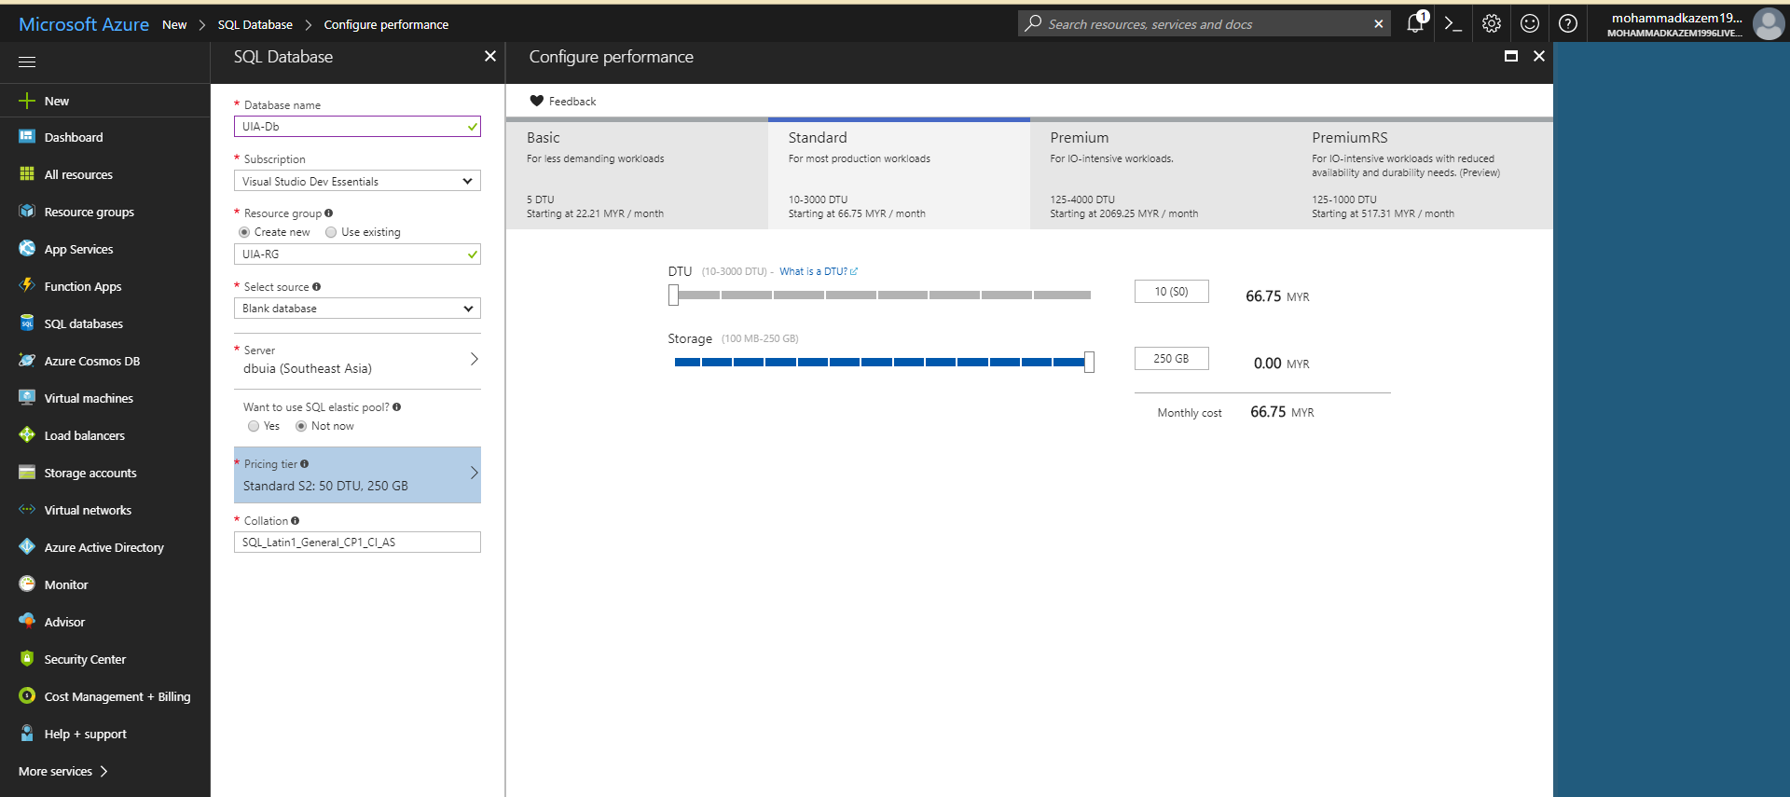

Figure . Chosen Database Service Tier

Furthermore, as the development office is located within Malaysia and UIA is planning to expand their business to the SEA region, the region chosen to deploy the database is Southeast Asia (SEA), as shown below. The interzone traffic is imminent as there are no regions between the two deployed regions (SEA and West Europe), without introducing two databases, which will significantly increase the operational cost, and increase the hassle for data synchronization and database management.

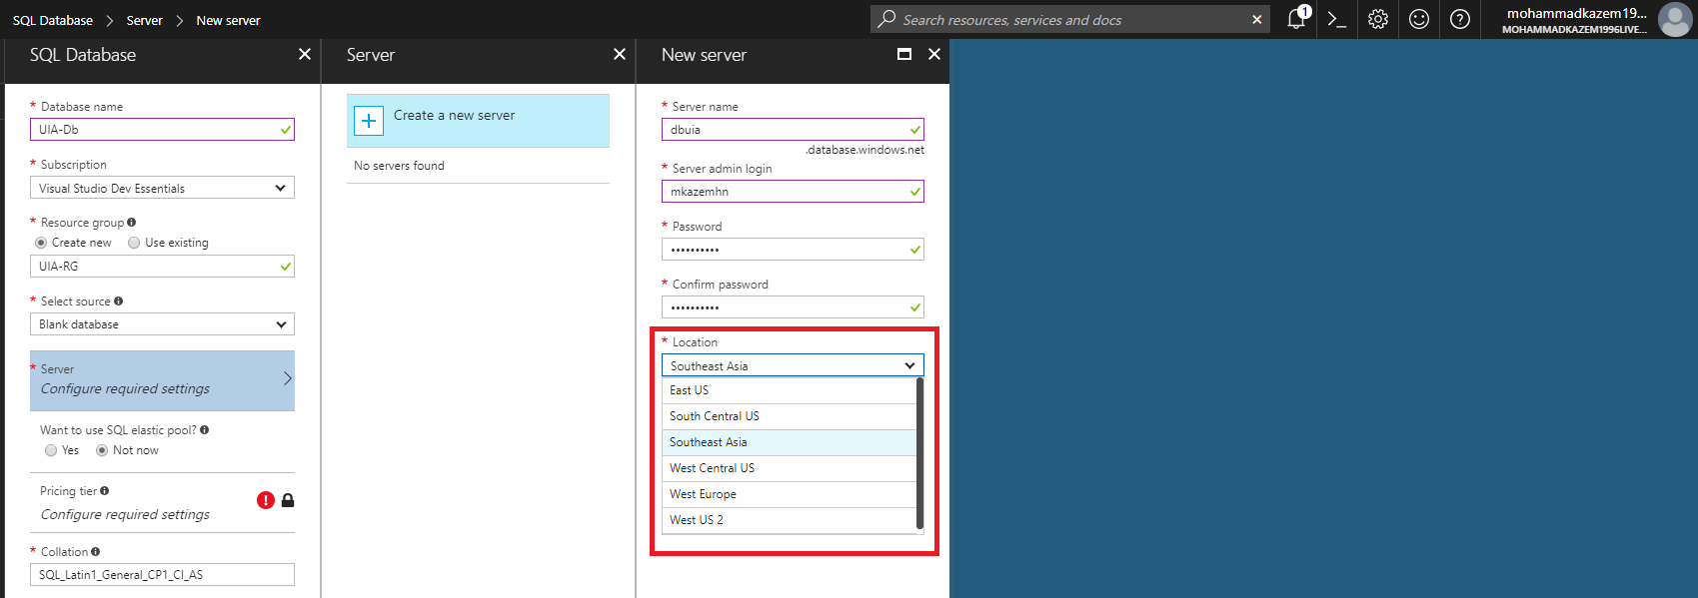

Figure . Database Server Location

After selecting the location, the database is isolated and managed on the created server as shown in the figure below.

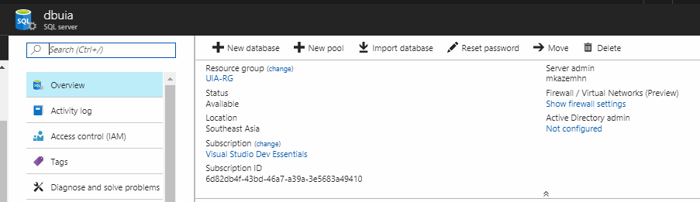

Figure . SQL Server

Lastly, as the developed web application has to handle confidential customer information and the privacy is of utmost importance, the database has been configured for three out of the four security measurements that Microsoft Azure provides within its database as a service, which are transparent data encryption, auditing, and threat detection, as shown below. Threat detection attempts to detect anomalous activity (such as SQL injections) that occur, while auditing constantly monitors and logs the database events, and transparent data encryption attempts to seamlessly encrypt the hosted database and its backups. These can be monitored through the security center within the Azure platform.

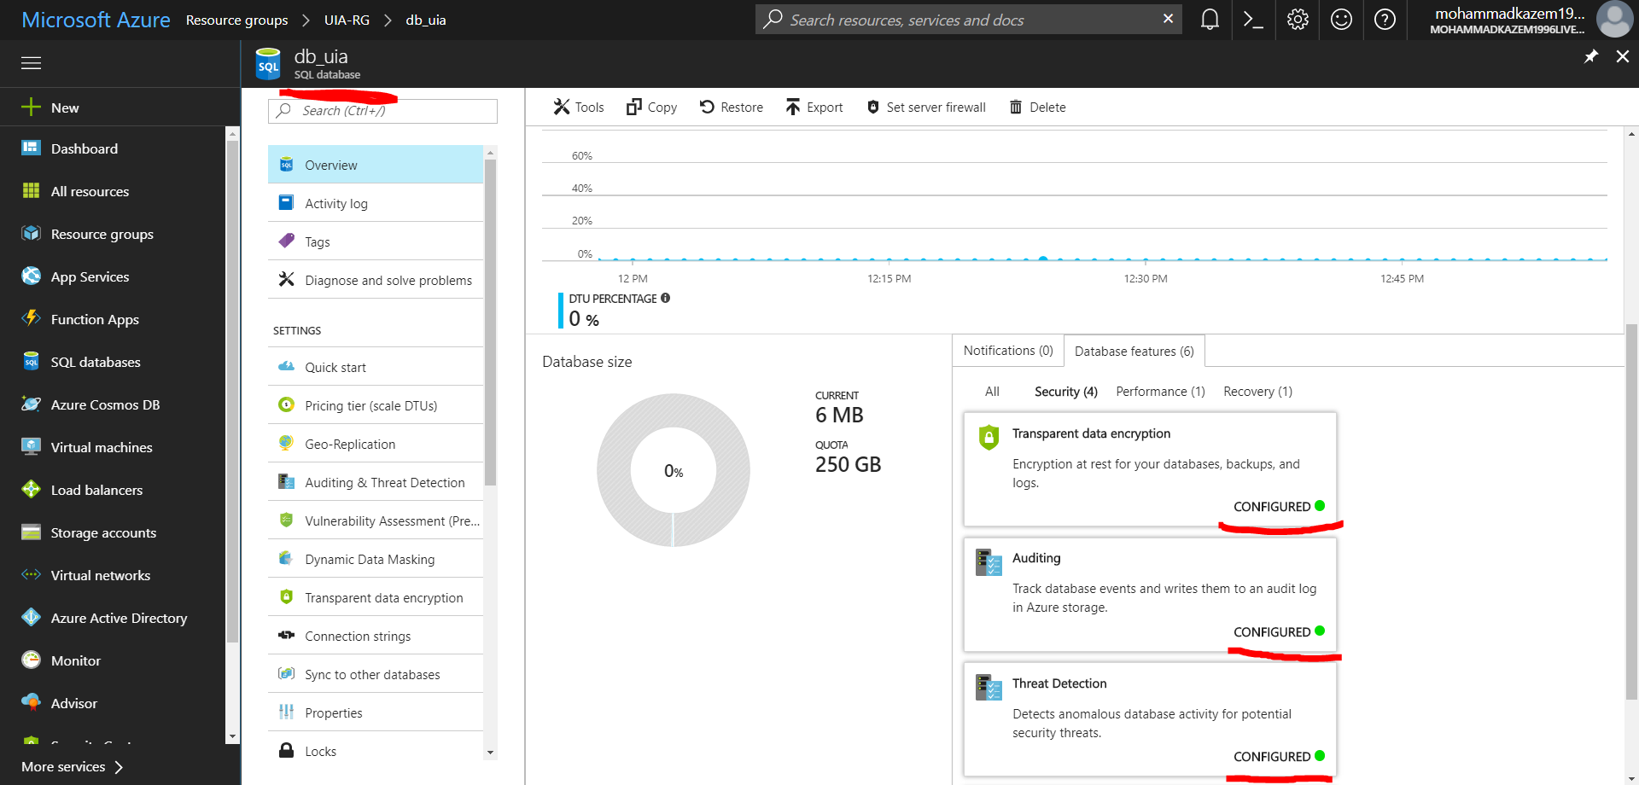

Figure . Database Security Settings

### 4.2.4 Traffic Manager

It is important to distribute user traffic for various endpoint services to improve responsiveness, availability, and implement an automatic failover when one of the endpoint fails (Dwivedi, et al., 2017). For instance, this will allow for zero downtime during peak seasons if there is a failure in one of the endpoints.

For virtual machines, this is often achieved through load-balancers, however for web apps, this can be directly achieved through an Azure Traffic Manager. This provides the ability to route traffic to the appropriate endpoint depending on the chosen routing method, and continuously monitor the endpoint health to automatically fall-back to another endpoint, incase an endpoint is down (maintenance or fault) without introducing any downtime. Furthermore, Azure Traffic Manager provides **four** routing methods, namely priority, weighted, performance, and geographic (Dwivedi, et al., 2017). The most suitable routing method for this application is **performance**. This selects the endpoint that provides the lowest network latency for a user when the endpoints are distributed geographically, thus allowing the user to use the “closest” endpoint. It is preferable over both priority and weighted, as these can reduce the performance, in terms of latency, for the user, which is paramount as defined by the business needs. Furthermore, it is preferential over geographic routing method, as it is not necessarily true that the closest geographical endpoint (based on originating DNS query) would provide the lowest latency, which the geographic routing method would choose.

However, with performance routing-method, as UIA expands and more web apps are deployed within the same regions to improve performance, the traffic is distributed evenly across the available endpoints within that region. Furthermore, the performance routing method will fall-back to the next endpoint with the second lowest latency for the user if the first endpoint is degraded, an example is shown below.

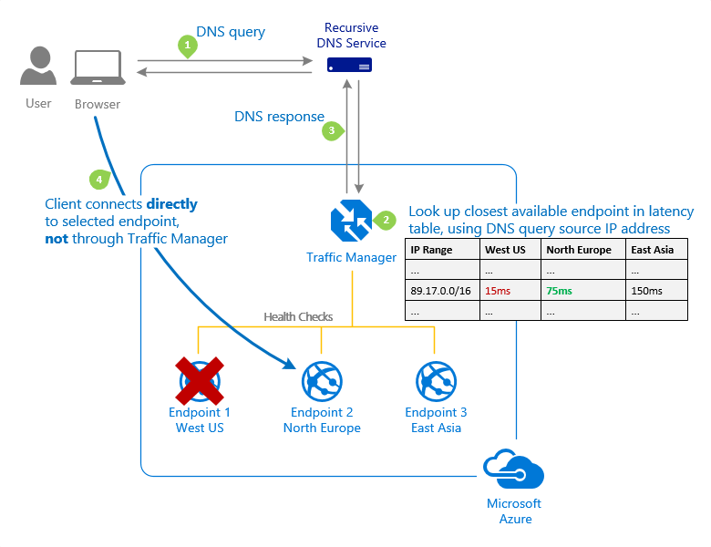

Figure . Traffic Manager Performance Routing Method (Dwivedi, et al., 2017)

The figure below depicts the two app services that are deployed in the two geographically different regions (SEA and West Europe), which have been chosen as the endpoints, as well as the DNS name that the user will query, through which the user will directly to the appropriate endpoint.

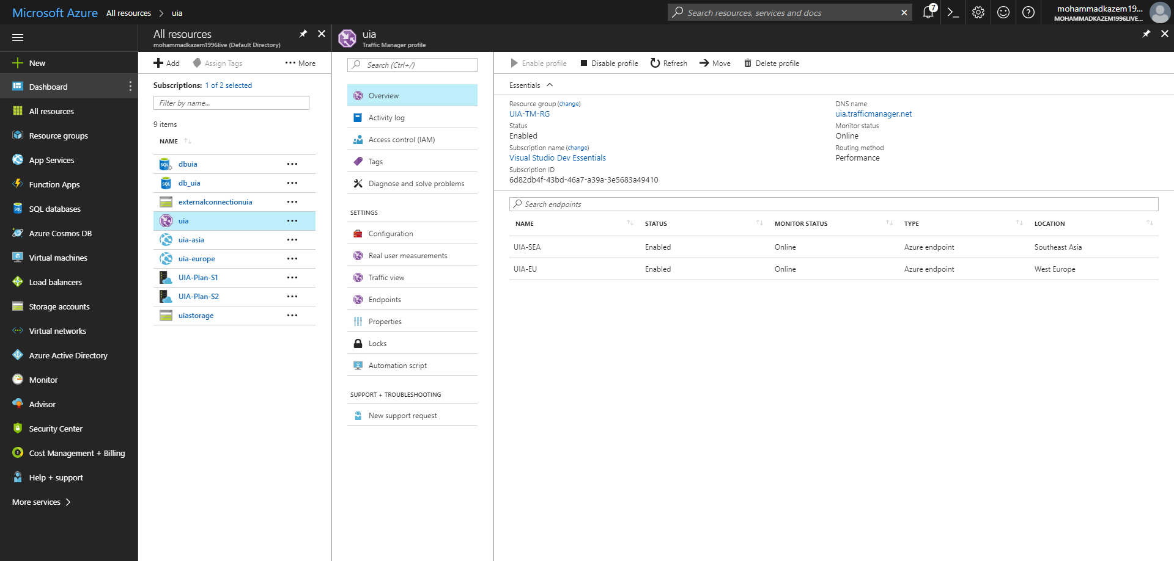

Figure . Traffic Manager Endpoints

To continually monitor the health of the endpoints, the path has been set to the /favicon.ico, which is a static path across almost all web applications, as shown below.

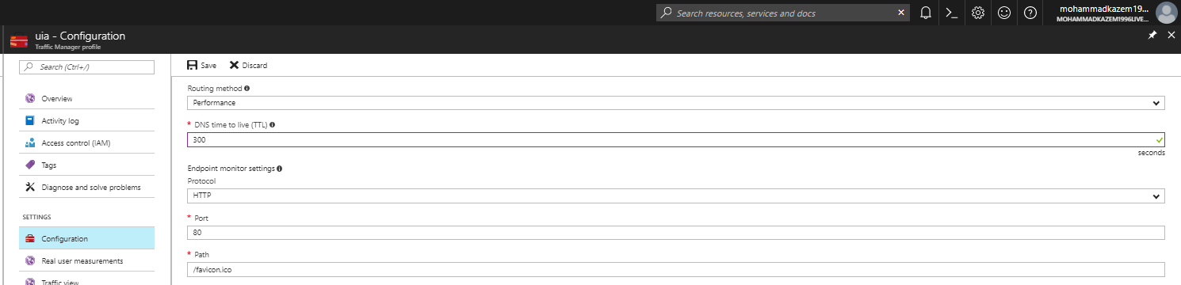

Figure . Traffic Manager Configuration

### 4.2.5 Application Insights

During the development of the web application, application insights was registered for the web application to collect, analyze, and investigate various aspects of the web application. Firstly, it provides perceptive information regarding varying levels of failed requests that can be further investigated with analyzing the corresponding GET/POST methods and the associated controller with the system/server exceptions that occurred, as shown below. The application insights were collected using the free tier that allows for up to 1 GB of data to be collected (through telemetry) as to eliminate any additional costs.

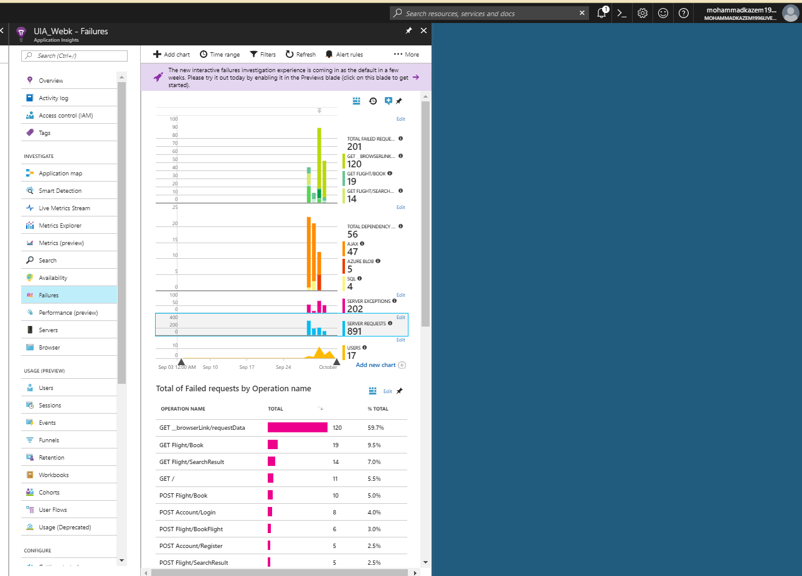

Figure . Application Insights - Failures

These allowed the developer to further investigate failures and commit changes that were pushed into the deployed web application, and also analyze the remote dependency calls, such as the pulling the latest configuration from the blob storage.

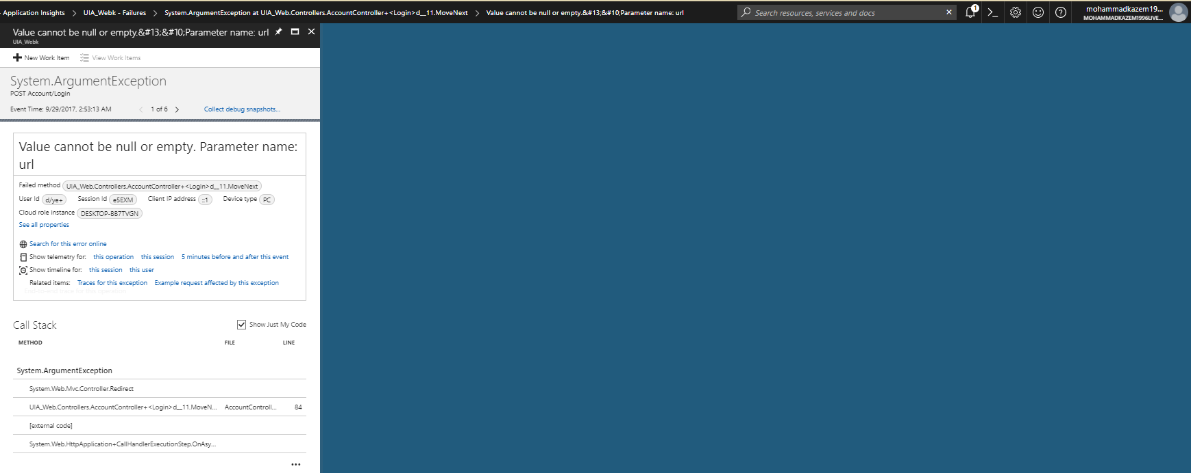

Figure . Example of exception during failure

Additionally, it allowed the developer to gain some metrical insight into the performance aspect of the application to further justify the need for scaling. However, based on the units of measurement, the application performed very well and the service plan that was chosen for it sufficed with the current load.

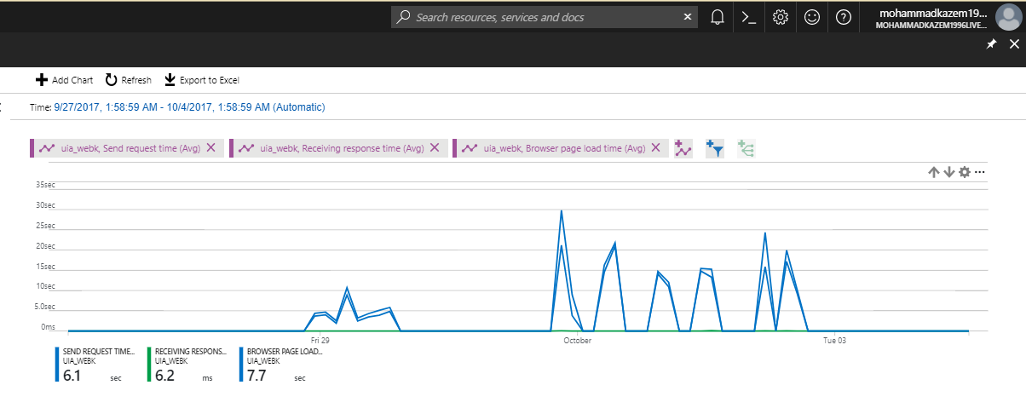

Figure . Performance Metrics - Application Insights

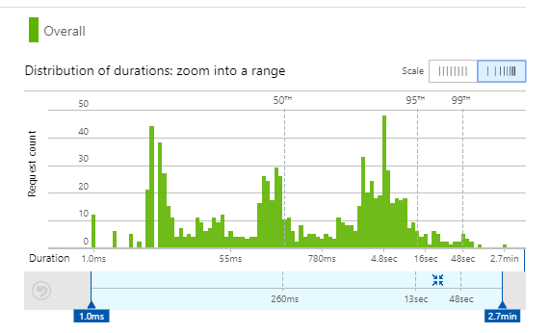

Figure . Response Time Visual Map

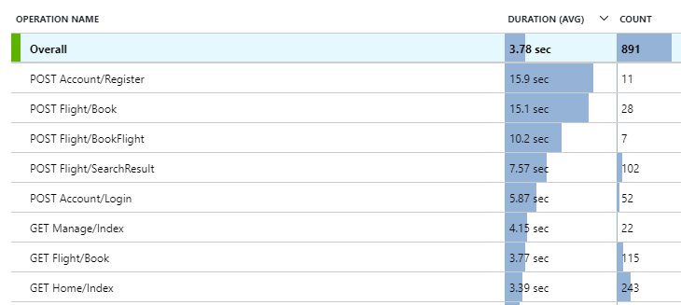

Figure . Response Time Analytics - Application Insights

### 4.2.6 Azure Blob Storage

The implemented cloud design pattern, external configuration store, calls for a centralized location through which the deployed web applications can upload and read the latest configuration file from. Microsoft Azure provides blob storage as a service that stores unstructured data or binary objects in the cloud (Myers, et al., 2017). The number of transaction units chosen for this blob storage was 10,000 as the web applications are highly remotely dependent on the configuration container, and query for the configuration information constantly. The configuration container that has been set-up as a blob storage for the external configuration store is shown below.

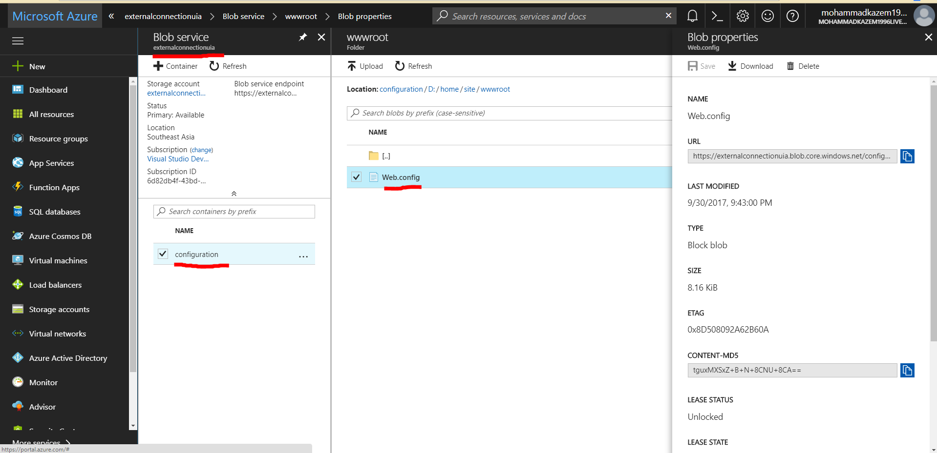

Figure . Configuration Container – Blob Storage

Lastly, another blob storage was used to store the auditing logs through the configured security measurement, as shown below.

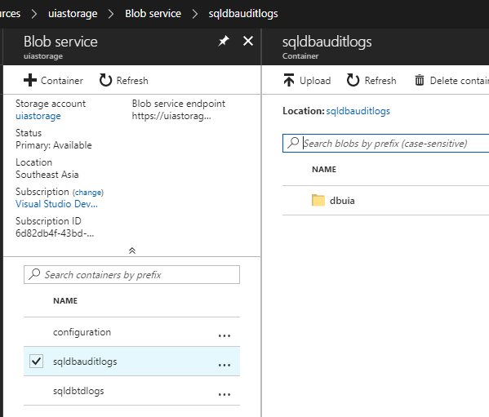

Figure . Auditing Log Container - Blob Storage

# 5.0 Testing

## 5.1 Test Plan

### 5.1.1 Functional Testing

Functional testing is a core testing approach that assures the conformance of the developed functions/modules per the requirement specification. This will allow the different features to be tested in terms of their functionality under different scenarios, and the actual result is compared to the expected result. The functional test cases will run after the development phase. For this project, the scope of modules that are to be tested and those that will be excluded need to be defined. The features that will be tested under the functional test are:

* **Login**
* **Register**
* **Search Flight**
* **Geo-IP Based Currency**
* **Book Flight**

The modules that are out-of-scope for the functional test are:

* **Modify User Details** – all the various functionalities needed are being covered with the other features, therefore it would be redundant.
* **Change Password** – it is using a well-established module (as part of the ASP.NET Identity System provided by Microsoft), therefore it has been well-tested prior to this project.

Table . Functional Test Plan

| ID | Feature/Function Tested | Test Procedure/Scenario | Description | Expected Result | Priority |
| --- | --- | --- | --- | --- | --- |
| **FT1** | Login | User presses on the Sign in button in the navigation bar.  User fills out his username and password correctly.  User presses on the login button. | This test involves testing the login module when a user has already registered and attempts to login with their correct credentials and the sign-in manager that is used to authenticate the user. | User is authenticated and cookie created.  User is redirected to the home page.  The user’s email is viewed as login in the top right corner of every webpage. | High |
| **FT2** | Search Flight | User has logged in.  User chooses the trip type, seat class, origin, destination, departure date, and return date.  User presses search flight. | This test involves checking one of the primary requirements of the system, which is to allow for users to search for flights based on their needs. | Database is queried for available flights for the specified criteria.  User is redirected to the result page that displays the respective flights and their prices | High |
| **FT3** | Book Flight | User has searched for his flight of choice.  User presses on the book button on the flight search result page.  User selects his/her desired available seat.  User fills out the passenger details.  User reviews the flight details.  User fills out payment details  User presses on the confirm button. | This test encapsulates one of the primary modules that is required as part of the system requirements, which is to successfully book a flight ticket based on the search result. | Records are added to the database.  User is re-directed to the confirmed booking webpage. | High |
| **FT4** | Register User | User wants to search and book a flight, but doesn’t have a customer profile.  User presses on the register button in the navigation bar.  User fills out the needed details.  User presses on the register button. | This test focuses on one of the primary requirements of the project, which is the creation of customer profiles, by testing its functionality and conformance to the requirement itself. | User validation is done.  Identity created for user.  User properties are inserted into the database.  User is authenticated and cookie created.  User is redirected to the home page.  The user’s email is viewed as login in the top right corner of every webpage. | High |
| **FT5** | Register User | User wants to search and book a flight, but doesn’t have a customer profile.  User presses on the register button in the navigation bar.  User fills out some of the needed details.  User presses on the register button. | This test involves checking how the validation of one of the primary requirements of the system, which is the creation of customer profile. | The system validates the model.  If, invalid then the system returns the set of fields that were invalid back in the view. | Low |
| **FT6** | Geo-IP based Currency | User views the homepage from Malaysia.  User scrolls to the Available Flights section and views the prices. | This test involves the conformance to one of the main requirements, which is providing customized information to the customer based on their location. | System extracts the user’s IP address from the request’s “REMOTE_ADDR” variable.  System sends a request to freegeoip.net using their free API.  System parses the JSON response and extracts the country.  For country_name “Malaysia”, “RM” is displayed as the currency in the homepage. | High |
| **FT7** | Geo-IP based Currency | User views the homepage from Finland.  User scrolls to the Available Flights section and views the prices. | This test involves the conformance to one of the main requirements, which is providing customized information to the customer based on their location. | System extracts the user’s IP address from the request’s “REMOTE_ADDR” variable.  System sends a request to freegeoip.net using their free API.  System parses the JSON response and extracts the country.  For country_name “Finland”, “€” is displayed as the currency in the homepage. | High |
| **FT8** | Search Flight | User has logged in.  User chooses the trip type, seat class, origin, departure date, and return date, but leaves the destination field empty  User presses search flight. | This test involves checking how the validation of one of the primary requirements of the system is done, which is searching for a flight. | The system validates the SearchFlightView model.  If, invalid then the system returns the set of fields that were invalid back in the view. | Low |
| **FT9** | Book Flight | User has searched for his flight of choice.  User presses on the book button on the flight search result page.  User selects his/her desired available seat.  User fills out the passenger details.  User reviews the flight details.  User fills out payment details  User presses on the confirm button. | This test involves checking how the validation of one of the primary requirements of the system is done, which is book a flight after the search result. | The system validates the SearchFlightView model.  If, invalid then the system returns the set of fields that were invalid back in the view | Low |

### 5.1.2 Performance Testing

Performance testing is another vital software test that assesses the performance software quality metrics in terms of several units of measurement. Firstly, it can be measured in terms of throughput, which can be defined in terms of total number of requests per second. Secondly, it can be measured through the average response time or average latency that provides an insight as to how the current web application can handle varying loads and its impact to the performance, which will allow the developer to identify if the web application requires to be scaled or as-to the breaking point (stress testing) that will allow the developer to identify the conditions under which the web application needs to be scaled. For instance, when the CPU percentage is over 90% or if the average response time is above 20s.

Microsoft Azure allows for the execution of performance tests for a web app that has been deployed. It is done through the Visual Studio Team Services (VSTS) that provides 20,000 virtual user minutes (VUM) for free. The VUM is a product of the concurrent user load and the duration of the performance test, as shown in the table below. It is important to note that throughout each performance test, the instance count will remain 1.

Table . Performance Test Plan

|  |  |  |  |  |
| --- | --- | --- | --- | --- |
| **Test No.** | **User Load** | **Duration (minutes)** | **Service Tier** | **Virtual User Minutes (VUM)** |
| 1 | 100 | 2 | S1 | 200 |
| 2 | 300 | 2 | S1 | 600 |
| 3 | 500 | 2 | S1 | 1000 |
| 4 | 1000 | 2 | S1 | 2000 |
| 5 | 100 | 2 | S2 | 200 |
| 6 | 300 | 2 | S2 | 600 |
| 7 | 500 | 2 | S2 | 1000 |
| 8 | 1000 | 2 | S2 | 2000 |
| 9 | 100 | 2 | S3 | 200 |
| 10 | 300 | 2 | S3 | 600 |
| 11 | 500 | 2 | S3 | 1000 |
| 12 | 1000 | 2 | S3 | 2000 |
| **Total: 11,400 VUMs** | | | | |

## 5.2 Results & Analysis

### 5.2.1 Functional Tests

The functional tests were performed manually without the usage of automated tools such as IntelliTest or Visual Studio’s in-built Unit Test. The results are based on the test cases that were defined in the prior section. The table below shows the set of results achieved through the execution of the test cases defined.

Table . Functional Test Results

| ID | Actual Result | Status |
| --- | --- | --- |
| FT1 | **As expected** | **Pass** |
| FT2 | **As expected** | **Pass** |
| FT3 | **As expected** | **Pass** |
| FT4 | **As expected** | **Pass** |
| FT5 | **New record inserted into the database with several empty fields** | **Fail** |
| FT6 | **As expected** | **Pass** |
| FT7 | **As expected** | **Pass** |
| FT8 | **New record inserted into the database with several empty fields** | **Fail** |
| FT9 | **New record inserted into the database with several empty fields** | **Fail** |

The results of the functional test dictate that several of the test cases had actually failed. However, these are mainly low-priority that does not directly affect the achievement of the requirements, and can be implemented within the next commits for the deployed web application. These were mostly validation issues, and as the web application serves as a proof of concept, as set by the well-defined scope of the project, validation was not necessary as the deliverable is not to deliver a fully commercial web application. Overall, majority of the test cases had passed, most notably, all of the test cases that were directly related to the requirements of the project.

### 5.2.2 Performance Tests

The performance tests were carried out as planned in the prior section. Microsoft Azure provides numerous data-points that were captured across each performance test, which were the throughput, average latency, user load, and other metrics. The figures below illustrate the various captured information through Microsoft Azure through the respective 100, 300, 500, and 1000 concurrent user load increments.

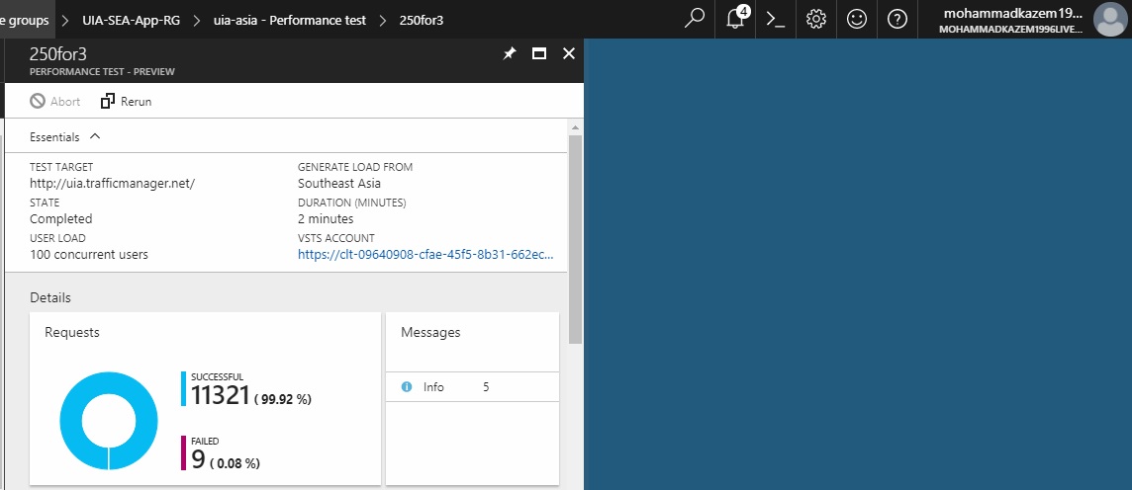

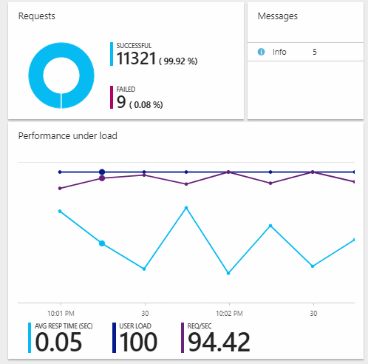

Figure . Performance Metrics - S1 - 100 Concurrent Users

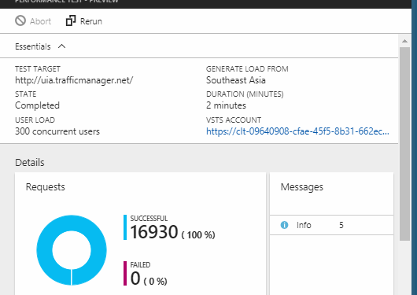

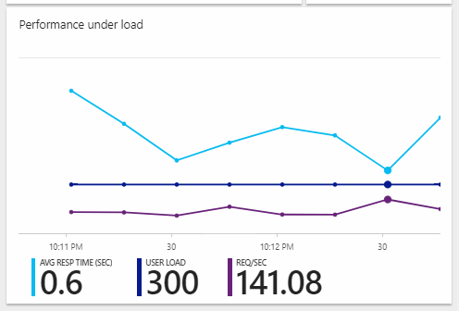

Figure . Performance Metrics - S1 - 300 Concurrent Users

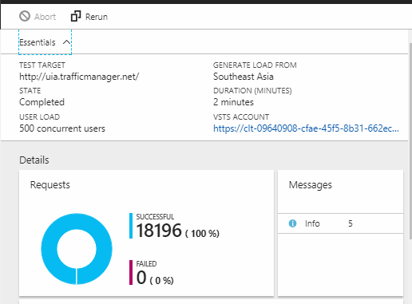

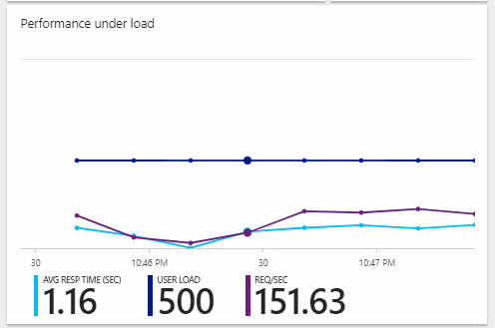

Figure . Performance Metrics - S1 - 500 Concurrent Users

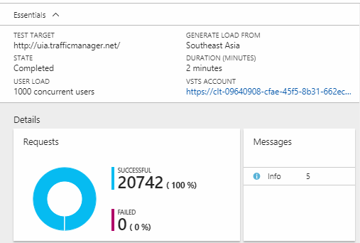

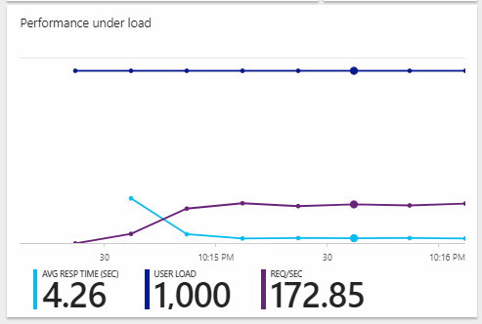

Figure . Performance Metrics - S1 - 1000 Concurrent Users

The web application was then scaled-up to an S2 service plan and the same measurements were taken, after which it was scaled-up to an S3 service plan and the same measurements were taken one last time. The data points captured across all the 12 performance tests were then comparatively evaluated, as shown in the tables below.

Table . Throughput every second across varying user load and service tiers

|  |  |  |  |
| --- | --- | --- | --- |
| Service Tier  User Load | S1 | S2 | S3 |
| 100 | 94.42 req/sec | 115.25 req/sec | 125.54 req/sec |
| 300 | 141.08 req/sec | 155.32 req/sec | 165.44 req/sec |
| 500 | 151.63 req/sec | 165.54 req/sec | 174.65 req/sec |
| 1000 | 172.85 req/sec | 179.54 req/sec | 180.29 req/sec |

The throughput, which is measured as the number of requests per second, naturally increases as the userload increases. The results can then be visualized to provide a more meaningful representation of the collected data points. From the chart below, there are numerous takeaways that mark the importance of the throughput as part of the performance test. It can be seen that there a general increase in throughput across an increase in the number of user load. However, there is no major difference between the throughput across high load of 500 and 1,000 concurrent users, while the web application running the S1 tier performed relatively poorly with 100 and 300 concurrent users when compared to S2 and S3. However, there was no major difference seen between S2 and S3 within these two user loads that would justify the **doubled cost** between S2 and S3.

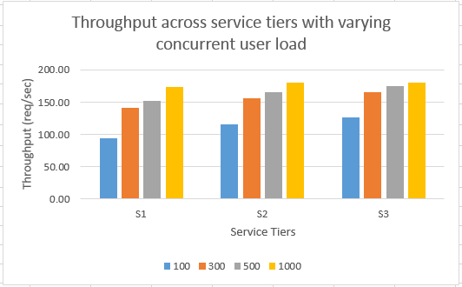

Figure . Throughput across service tiers with varying concurrent user load chart

The second set of metrics that were calculated through the collected data points is the average latency with variance in the concurrent user loads. This has been captured in the table below.

Table . Average Response Time across varying user load and service tiers

|  |  |  |  |
| --- | --- | --- | --- |
| Service Tier  User Load | S1 | S2 | S3 |
| 100 | 0.05 sec | 0.05 sec | 0.04 sec |
| 300 | 0.6 sec | 0.32 sec | 0.5 sec |
| 500 | 1.16 sec | 0.95 sec | 0.86 sec |
| 1000 | 4.26 sec | 3.43 sec | 3.2 sec |

There is a general increase in the latency, as expected, across all the service tiers when the number of concurrent users increases. However, there is a notable increase from 500 to 1,000 concurrent users, especially with S1. However, S2 and S3 have performed almost equally, however S3 costs double as much as S2.

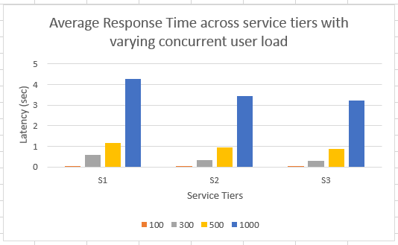

Figure . Latency across service tiers with varying concurrent user load chart

Therefore, based on the results that were collected and visualized, it can be seen that there is a notable difference between S1 and S2 with the variance in the concurrent user load across both the throughput and the average response time (latency), which justifies the price difference. However, there was slight improvements in throughput and reduction in average response time across all the concurrent varying loads between S2 and S3, which indicates that the performance provided by the S3 is not well-justified for the doubled cost against S2, even though the resources were doubled. Therefore, the most justifiable scale-up option is to scale from S1 to S2 to meet the high demands during peak seasons, as S1 performs well enough during normal seasons, and S2 has shown drastic improvements with over 500 concurrent user load.

# 6.0 Conclusion

Ukraine International Airlines has come a long way since its establishment. Over the period of 15 years, they have placed a strong footing within the competitive airline market with a dominance of over 20% of the market segment. However, due to the recent political and economic instability, and de-valuation of the Ukrainian currency, UIA was striven to remain competitive through strategical overhauls to their staff, routes, and carriers resulting in reduction in ticket fares to enable them to further internationalize their services and contend as one of the world's low-fare carriers. UIA has long used technology to help reduce costs and improve customer service. The Chief Information Officer of UIA has realized that through migration of their website out of their own datacenters into the public cloud, they can further gain a competitive advantage over their competitors and improve customer services with the extensive set of tools and services that are provided.

The aim of this project was to develop and deploy a single-tenant flight booking web application with the minimal requirements of customer profile creation, management of the entire booking process, and customized information based on user location. The development that was based in Malaysia had a budget of RM 150 to utilize for the efficient design of a cloud architecture with the necessary Azure services to achieve the set deliverables.

The web application, which was developed using the MVC architecture complemented with Entity Framework, utilized ASP.NET Identity System for secure authentication of the user, GeoIP-based currency to provide varying currencies based on the user’s geographical location, and dynamic seat picker to further enhance the user experience.

The cost of the various Azure services were broken down to analyze and dictate the service plans that were required and the associated cost with each necessary Azure service. The web application was deployed in two regions, Southeast Asia, as the software development team is located primarily in Malaysia, and UIA is planning to expand their carrier network, and secondly, West Europe, as UIA’s headquarter functions in Ukraine, and this is the closest region to Ukraine. The web applications were configured for continuous delivery and to scale-out to meet the demands during peak seasons. The Azure SQL Database was configured for numerous security measurements to further enhance the database security and monitoring due to the criticality of the privacy and confidentiality of the information. Traffic manager was also implemented to allow for the effective distribution of user load based on the performance routing method and continuous endpoint health monitoring. Furthermore, application insights was added to the SEA web application to gather, analyze, and investigate numerous metrics, such as performance as well as failed requests (with raised exceptions) during the development and deployment phase. However, the free version was used, which provided up to 1GB of free data storage through telemetry. Lastly, two blob storage containers were set-up, first of which allowed for the implementation of the external configuration store cloud design pattern, and the second of which was used for the auditing logs as part of the active security configuration of the Azure SQL database. After the implementation phase, the developed modules were tested in terms of functionality to ensure the compliance of the modules to the defined requirements. Additionally, performance testing was done to analyze how the application can handle user load at varying concurrent user load sizes with different service tiers to find the optimal scale-up solution, through which the developer concluded that S2 provides the best performance for its given price, while S1 will suffice for non-peak seasons, and S3 was well-beyond justifiable given its enormous cost (triple the price of S1) and the minor performance enhancement that it provides.

There are several future enhancements that can be proposed to enhance and further advance the web application. Firstly, by utilizing the cache-aside pattern, the implemented cloud design pattern, external configuration store, can be complemented, as it will require lesser remote dependency on the centralized location, as it will only update once there is a change, while the configuration is held inside the cache. Secondly, if there were no budget constraints, then the premium service tiers would provide in magnitudes higher performance as evident through the comparative table shown previously. Lastly, the web application can be deployed in more than two regions as UIA is planning to further expand their aircraft network, which will allow users to experience better performance when using the web application with a nested traffic manager that manages the various endpoints in all supported regions.

All in all, the web application was successfully developed by utilizing the services provided by Microsoft Azure as a platform. It allowed the developer to gain an in-depth understanding of the various cloud computing forms and the services that are provided by Microsoft Azure, such as the traffic manager, application insights, performance test, continuous deployment, Azure SQL Database, and Blob storage. Furthermore, it allowed the developer to architecturally design an efficient application within the Azure platform as there was a budget constraint of RM 150 set. The developer also gained vast experience in developing a web application using the MVC architecture complemented with the latest technologies such as Entity Framework and ASP.NET Identity System.

References

Anderson, R. et al., 2017. *Introduction to Identity on ASP.NET Core.* [Online]   
Available at: https://docs.microsoft.com/en-us/aspnet/core/security/authentication/identity?tabs=visual-studio%2Caspnetcore2x

AnyChart, 2017. *Boeing 737.* [Online]   
Available at: https://www.anychart.com/products/anymap/gallery/Seat_Maps/Boeing_737.php

Dwivedi, K., Wheeler, S., Mauderia, J. & Tuliana, J., 2017. *Overview of Traffic Manager.* [Online]   
Available at: https://docs.microsoft.com/en-us/azure/traffic-manager/traffic-manager-overview

Dwivedi, K., Wheeler, S., Mauderia, J. & Tuliana, J., 2017. *Traffic Manager routing methods.* [Online]   
Available at: https://docs.microsoft.com/en-us/azure/traffic-manager/traffic-manager-routing-methods

Fiori, A., 2017. *IP geolocation web server.* [Online]   
Available at: https://github.com/fiorix/freegeoip

Forsyth, S., 2010. *Viewing all Server Variables for a Site.* [Online]   
Available at: https://weblogs.asp.net/owscott/viewing-all-server-variables-for-a-site

Lavrov, V. & Gordiienko, O., 2014. *Ukraine International Airlines, nation’s top, conceals ownership.* [Online]   
Available at: https://www.kyivpost.com/article/content/legal-quarterly/ukraine-international-airlines-nations-top-conceals-ownership-385153.html

LeBlanc, M., Wenzel, M. & Latham, L., 2017. *How to: Request Data Using the WebRequest Class.* [Online]   
Available at: https://docs.microsoft.com/en-us/dotnet/framework/network-programming/how-to-request-data-using-the-webrequest-class

Myers, T., Lin, C. & Shahan, R., 2017. *Get started with Azure Blob storage using .NET.* [Online]   
Available at: https://docs.microsoft.com/en-us/azure/storage/blobs/storage-dotnet-how-to-use-blobs

Narumoto, M., Bennage, C., Wasson, M. & Wood, P., 2017. *External Configuration Store pattern.* [Online]   
Available at: https://docs.microsoft.com/en-us/azure/architecture/patterns/external-configuration-store

Rabeler, C., Popovic, J., Crider, K. & Stein, S., 2017. *What is the Azure SQL Database service?.* [Online]   
Available at: https://docs.microsoft.com/en-us/azure/sql-database/sql-database-technical-overview

# Appendices

**Azure Account used**: [mohammadkazem1996@live.com](mailto:mohammadkazem1996@live.com)

**GitHub Private Repository**: <https://github.com/nhmezakm/UIA-FlightWeb>

**Microsoft Teams/OneNote Email**: [TP035903@mail.apu.edu.my](mailto:TP035903@mail.apu.edu.my)

**Traffic Manager URL**: uia.trafficmanager.net

**SEA Web App URL**: uia-asia.azurewebsites.net

**West-Europe Web App URL**: uia-europe.azurewebsites.net

**Microsoft Streams Presentation and Demonstration**: <https://web.microsoftstream.com/video/508f04dc-3404-4406-8997-73c86944b877>